# CSC2058 Peer Assessment 2: Back from the Brink

This Assessment Document is intended to provide you and your assessor with an overview of each group member’s involvement in the delivery of the CSC2058 Project.

Each group should complete one Assessment Document and its content must be agreed by all group members. The completed form should be included **at the start** of your group’s PDF report. ***Don’t forget to fill in the Group Number.***

There are two main parts to the Assessment Document – the Evaluation and the Declaration. Both parts must be completed – otherwise your group’s report will not be marked. Arrange a group meeting to discuss the evaluation, and **see the note below**!

|  |  |  |  |  |
| --- | --- | --- | --- | --- |
| **Evaluation** | Group Number: 40 | | | |
| Name | Contribution to team-working and motivation1 | Contribution to PDF Report 21,2 | Contribution to the Working System1,2 | **Peer Score**  (Range 85 – 115) |
| Daniel Mason | 5 | 5 | 5 | 115 |
| Niamh McLarnon | 5 | 5 | 5 | 115 |
| Michal Kennedy | 0 | 0 | 0 | 85 |
| Craig Mulligan | 1 | 1 | 0 | 85 |
| Charlotte Bisp | 1 | 1 | 0 | 85 |
| Omar Basha | 1 | 1 | 0 | 85 |

1Values for contribution: 1 = Minimal Contribution; 2 = Reasonable Contribution; 3 = Good Contribution; 4 = Very Good Contribution; 5 = Excellent Contribution

2This value should consider contributions in the round – direct contributions to required deliverables, and contributions that have made the deliverables possible.

|  |  |  |
| --- | --- | --- |
| **Declaration**  “I declare that I have read the Queen's University regulations on plagiarism, and that any contribution I have made to the attached submission is my own original work, except for any elements that I have clearly attributed to third parties. I understand that this submission will be subject to an electronic test for plagiarism and will also be subject to the University’s regulations concerning late submission if it is received after the deadline.” | | |
| Name | Date | Confirmation *(use the words shown in the example below!)* |
| Daniel Mason | 26/03/2021 | I agree with the terms and the declaration |
| Niamh McLarnon | 26/03/2021 | I agree with the terms and the declaration |
| Michal Kennedy | 26/03/2021 | I agree with the terms and the declaration |
| Charlotte Bisp | 26/03/2021 | I agree with the terms and the declaration |
| Omar Basha | 26/03/2021 | I agree with the terms and the declaration |
| Craig Mulligan | 26/03/2021 | I agree with the terms and the declaration |

***A note on the Evaluation:***

Complete **all** the columns in the Evaluation Table. The Contribution columns are intended to help team members quantify each other’s input to the project, before they award agreed **Peer Scores**. There will not necessarily be a precise correlation between the Peer Score and the Contribution values. However, high Contribution values, as an indicator of the importance of the team member’s work to the success of the project, should normally result in a high Peer Score for a team member. Likewise a low Peer Score would be the expected outcome if Contribution values are low. Students who have made a high-value Contribution in all three contribution categories (e.g. 5,5,5) should expect to receive a higher Peer Score than students who have made a lower-value Contribution in one or more categories (e.g. 5,5,3).

If, having reviewed the Contribution values, the team agrees that Team Member 1 made a minimal contribution overall, a Peer Score of 85 would be appropriate for Team Member 1. If Team Member 1’s contribution was excellent (critical to the success of the project in all areas of engagement), consider a peer score of 115. If Team Member 1 made a generally good contribution, doing what was expected of them, they could expect to receive a Peer Score of 100. It may be that a team member (for whatever reason) has disengaged from the project entirely, and in such circumstances a Peer Mark of 0 may be acceptable. ***Please inform the module Lecturer if a team member has left your group or has ceased to play an active role in the group.***

|  |  |
| --- | --- |
| Each team member’s overall score for the Semester 2 deliverable will be calculated according to the formula alongside, where S*i* is Team Member *i*’s overall score, P*i* is the Peer Score received by Team Member *i*, N is  the number of members in the team, and M is the raw mark awarded to the deliverable by the assessor. | $$S_{i}=\frac{P_{i}}{\frac{1}{N}\sum_{j=1}^{N}{P_{j}}} ×M$$ |

Any Peer Score within the range 85 – 115 will normally be accepted by the module Lecturer. **However, students are expected to award a range of marks within a team: it is very unusual in a project for everyone to display exactly the same level of ability and commitment, and the Peer Scores should reflect this.**  Be fair: be prepared to recognise someone who has adopted a leading role in the project, and acknowledge the fact that some contributions will be weaker than others. Uniform marks, or marks outside the range 85 – 115, may require that the Team discuss its decision with the module Lecturer, in order to agree a fair distribution of marks. Throughout the project, team members should use appropriately named folders in GitLab to help them co-ordinate their work and maintain a record of their contributions. Where team members cannot agree a distribution, or the distribution is unreasonable, the module Lecturer’s judgement will be final.

**The Final PDF Report & The Process**

**Group 40**

**Design Documentation**

**Text User Interface**

**[N.M]**

Intro/Outro

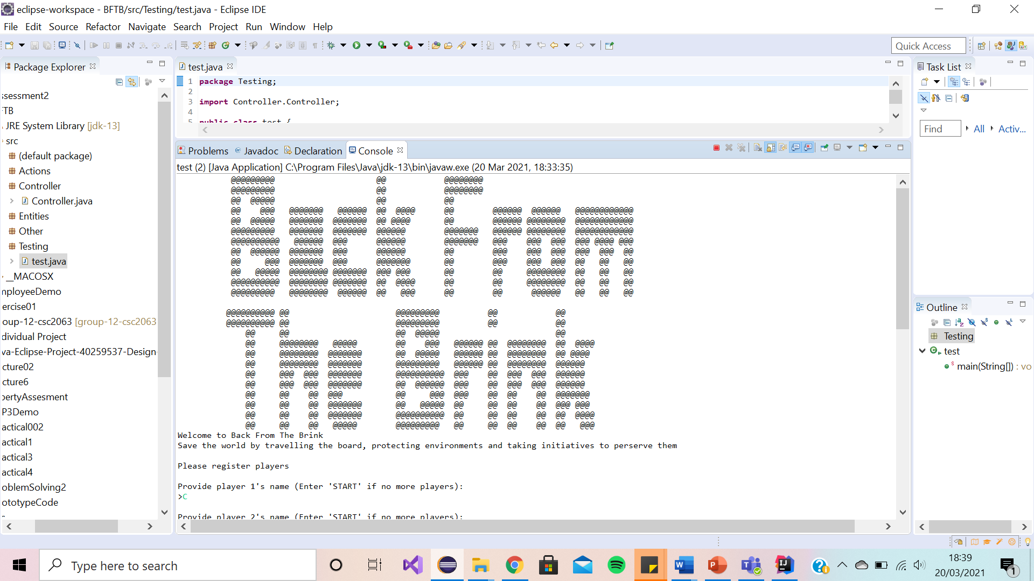

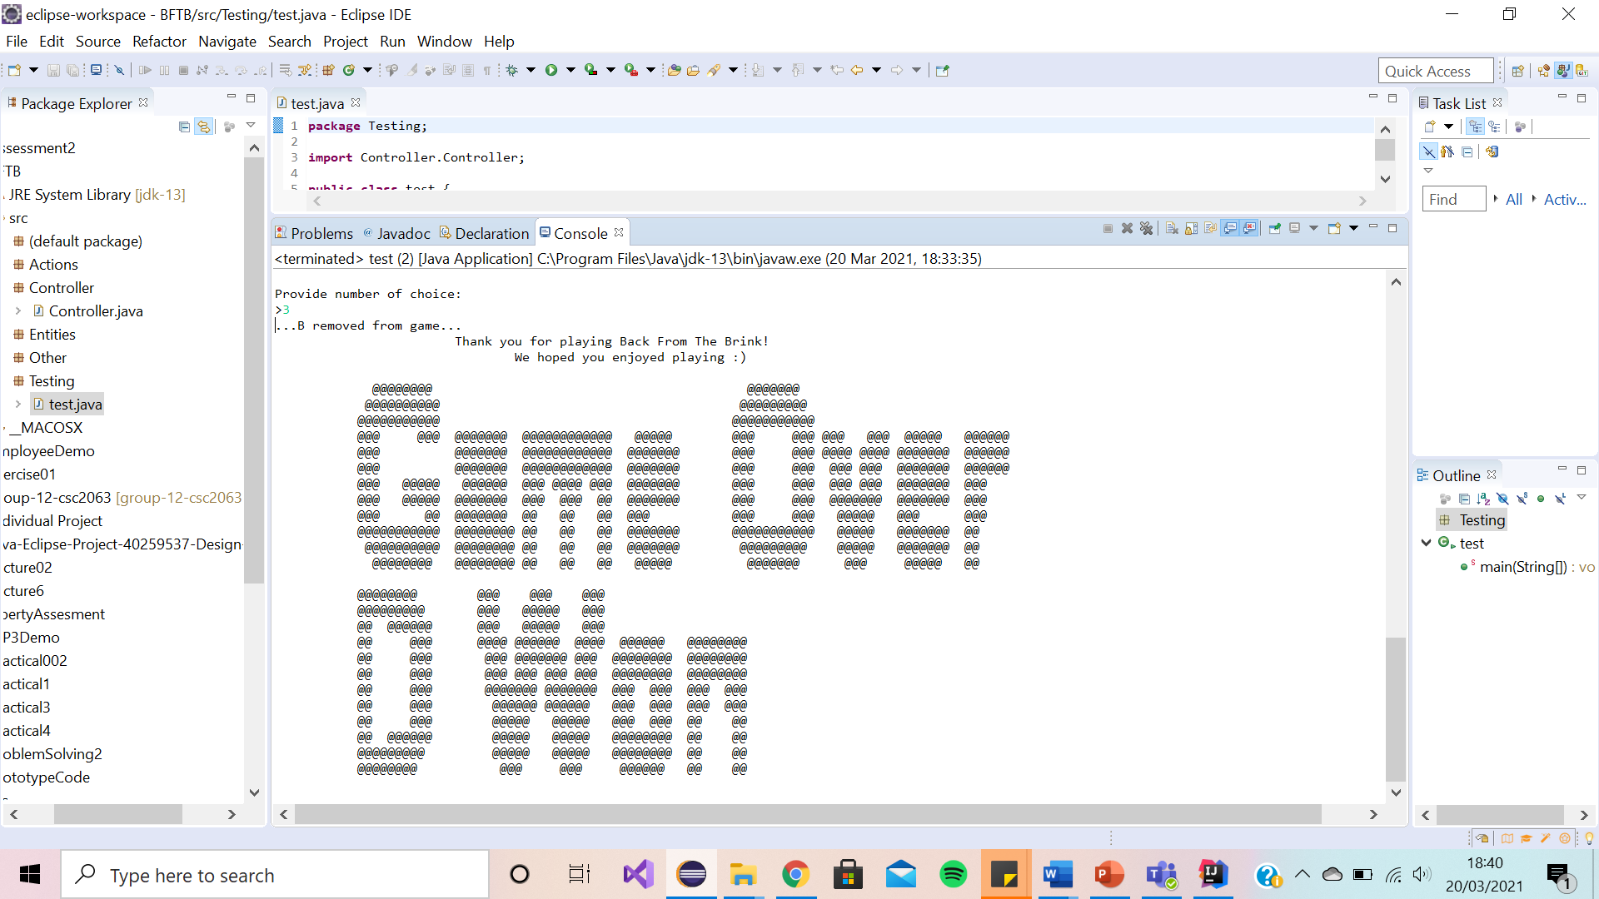

We have decided to use ASCII Art for the ‘Back from the Brink’ intro and outro to make the game more eye catching to the players. This will therefore draw in their interest.

Game Scenario Message

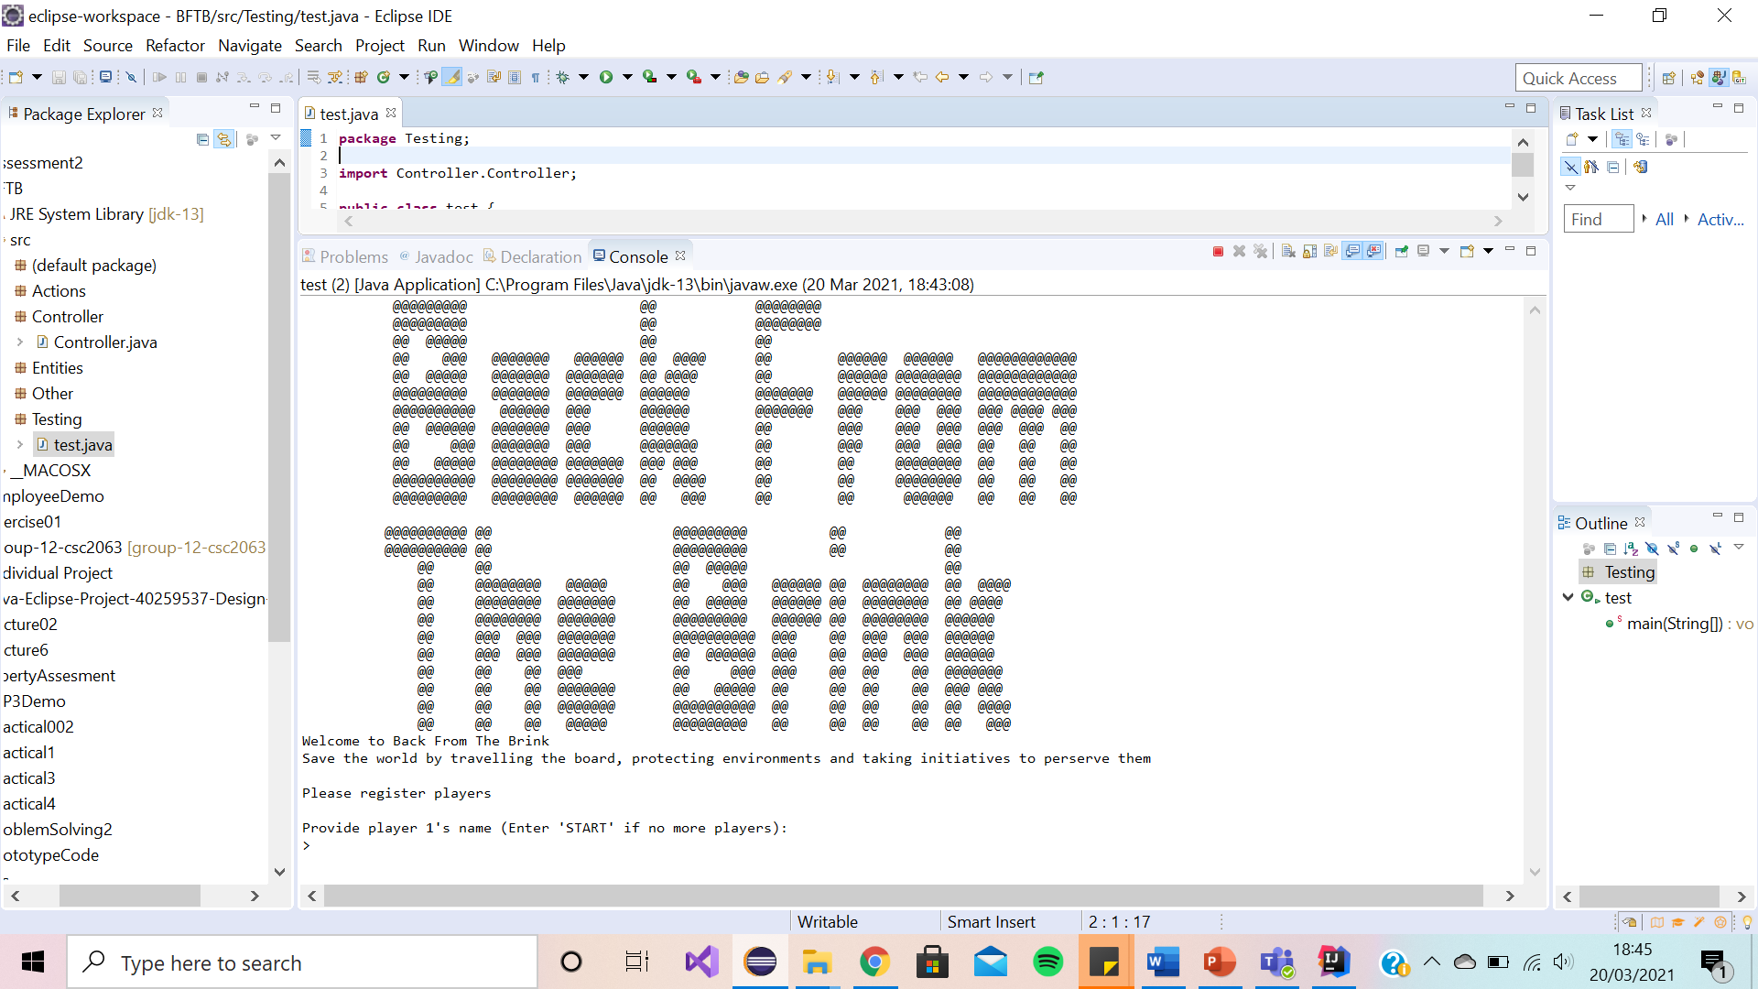

We have decided to lay the game scenario message (as shown above) as a print statement as it sets the scene for the players, attracting their interest from the start. We have kept it short to keep reading minimal therefore allowing the players to start the game quickly.

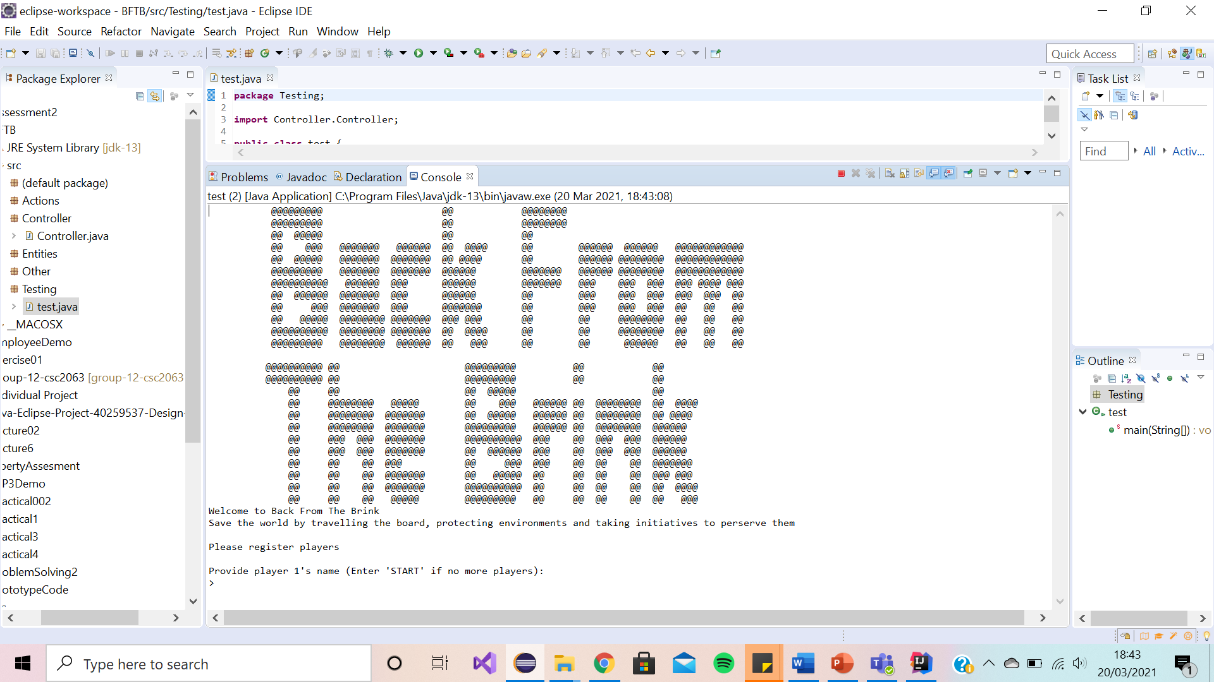Registering Players Prompt

We have decided to lay the registering players prompt (as shown above) as a simple enter your player’s name in the text box as it is brief and exactly tells the player what they must do to register themselves as a player to start the game.

Take Turn Prompt

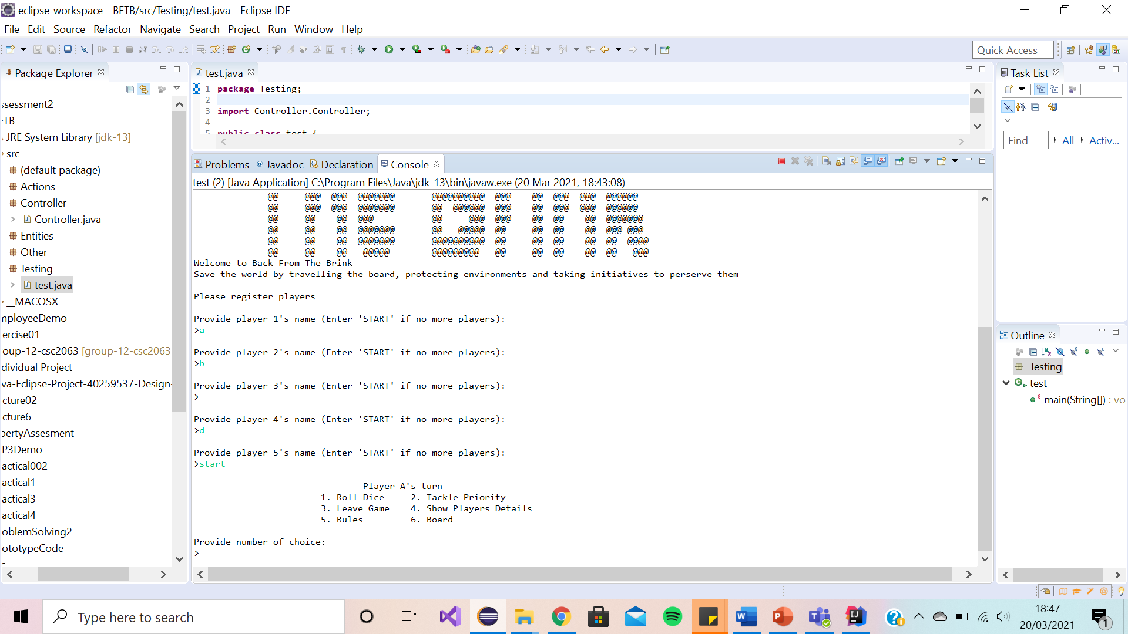

We have decided to lay the enter choice prompt (as shown above) as a switch statement as it clearly lays out the list of options the player to choose from. This avoids any human errors, and it reduces the amount of typing the user has. We have minimised the number of choices the player can chose from as having too many choices may over complicate the game for the player

Invalid Option Message

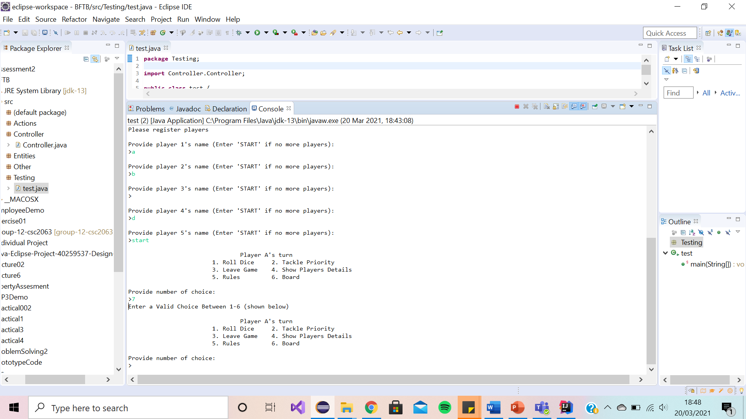

We have decided to lay the invalid choice prompt (as shown above) as a switch statement as it is concise, and it politely tells the user this is an invalid option. It suggests to them how they can resolve this error. This therefore helps the user to continue playing with the game.

Player Details (Summary)

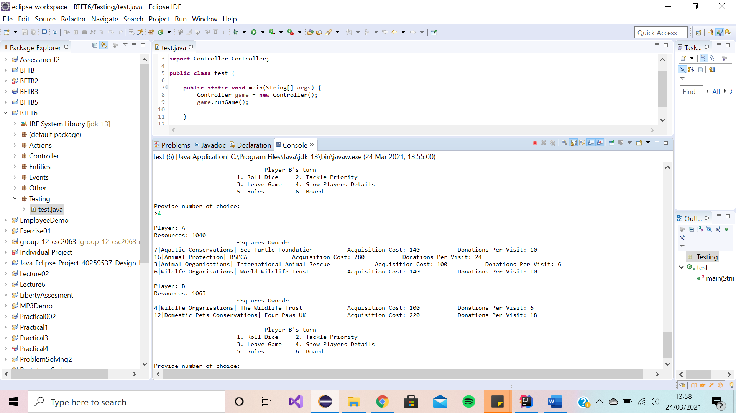

We have decided to lay the player details summary (as shown above) as a simple print statement. This provides the players with all the relevant details such as player names, player balance and their owned priorities (with their associated costs). We have chosen to show these details as we believe they are the most important and appropriate to the players.

Rules Message

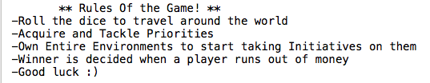

We have decided to lay the rules message (as shown above) as a simple print statement as players would not want a long paragraph of rules to try read and understand. It simply and clearly lays out the rules of the game.

Board Summary

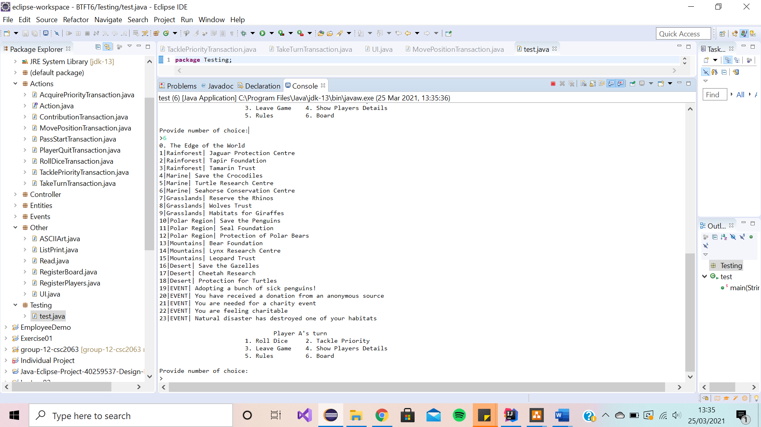

We have decided to include a board summary (as shown above) as a print statement to visualise for the player the board. We have included a list of all the priorities names on the board as well as surprise events.

Roll Dice/Move Player Prompt

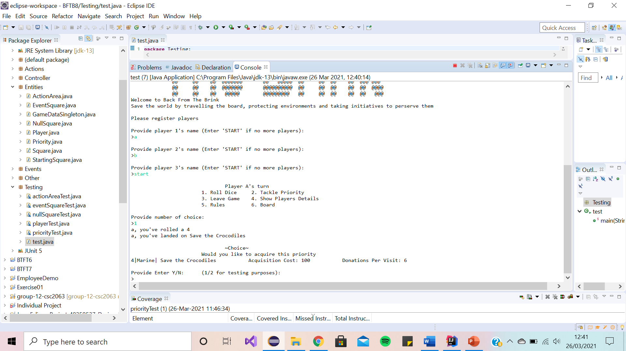

We have decided to lay the roll dice/move player prompt (as shown above) as it clearly tells the player what they have rolled, where they have landed on the board and it offers them the choice to acquire this priority (with the relevant cost). We have kept the choice simple and the layout minimal.

Acquiring Priority Message

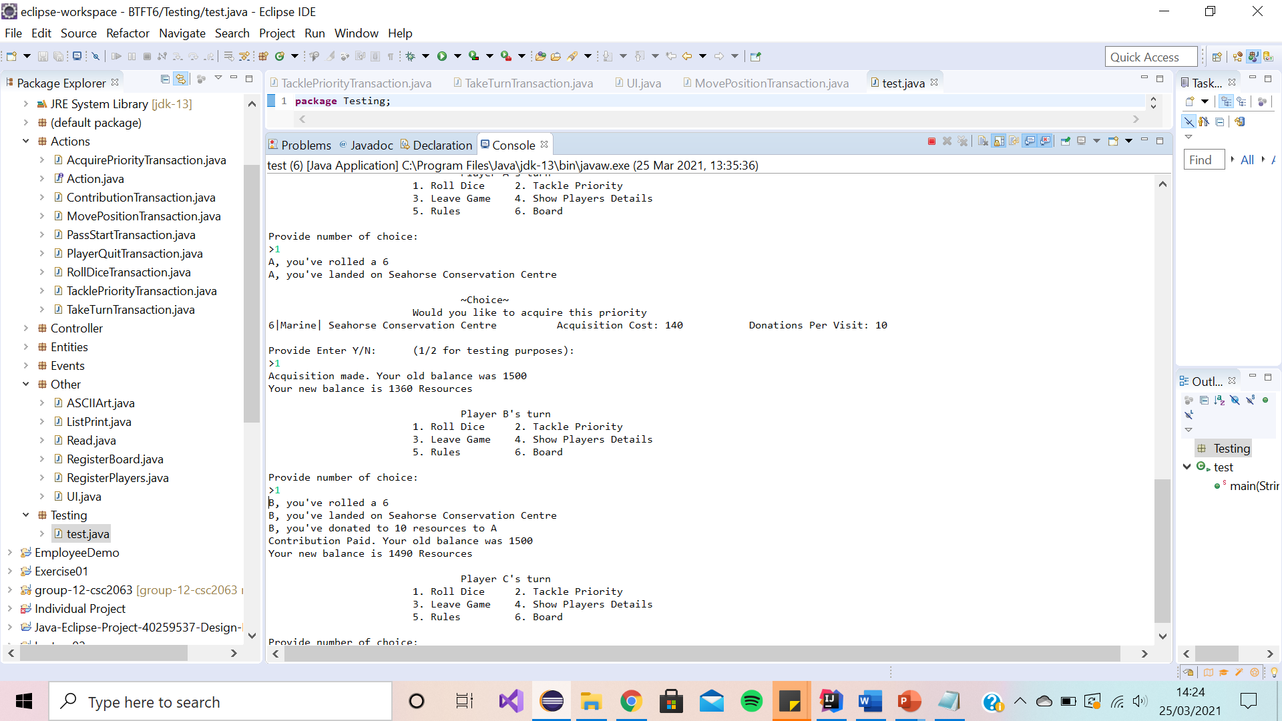

We have decided to the lay the acquiring priority choice (as shown above) it clearly lays out all the relevant details about the priority the player has landed on such as the action area it belongs to, the name of the priority and the associated costs. It also provides an update to the player on their updated balance

Contribution Transaction Message

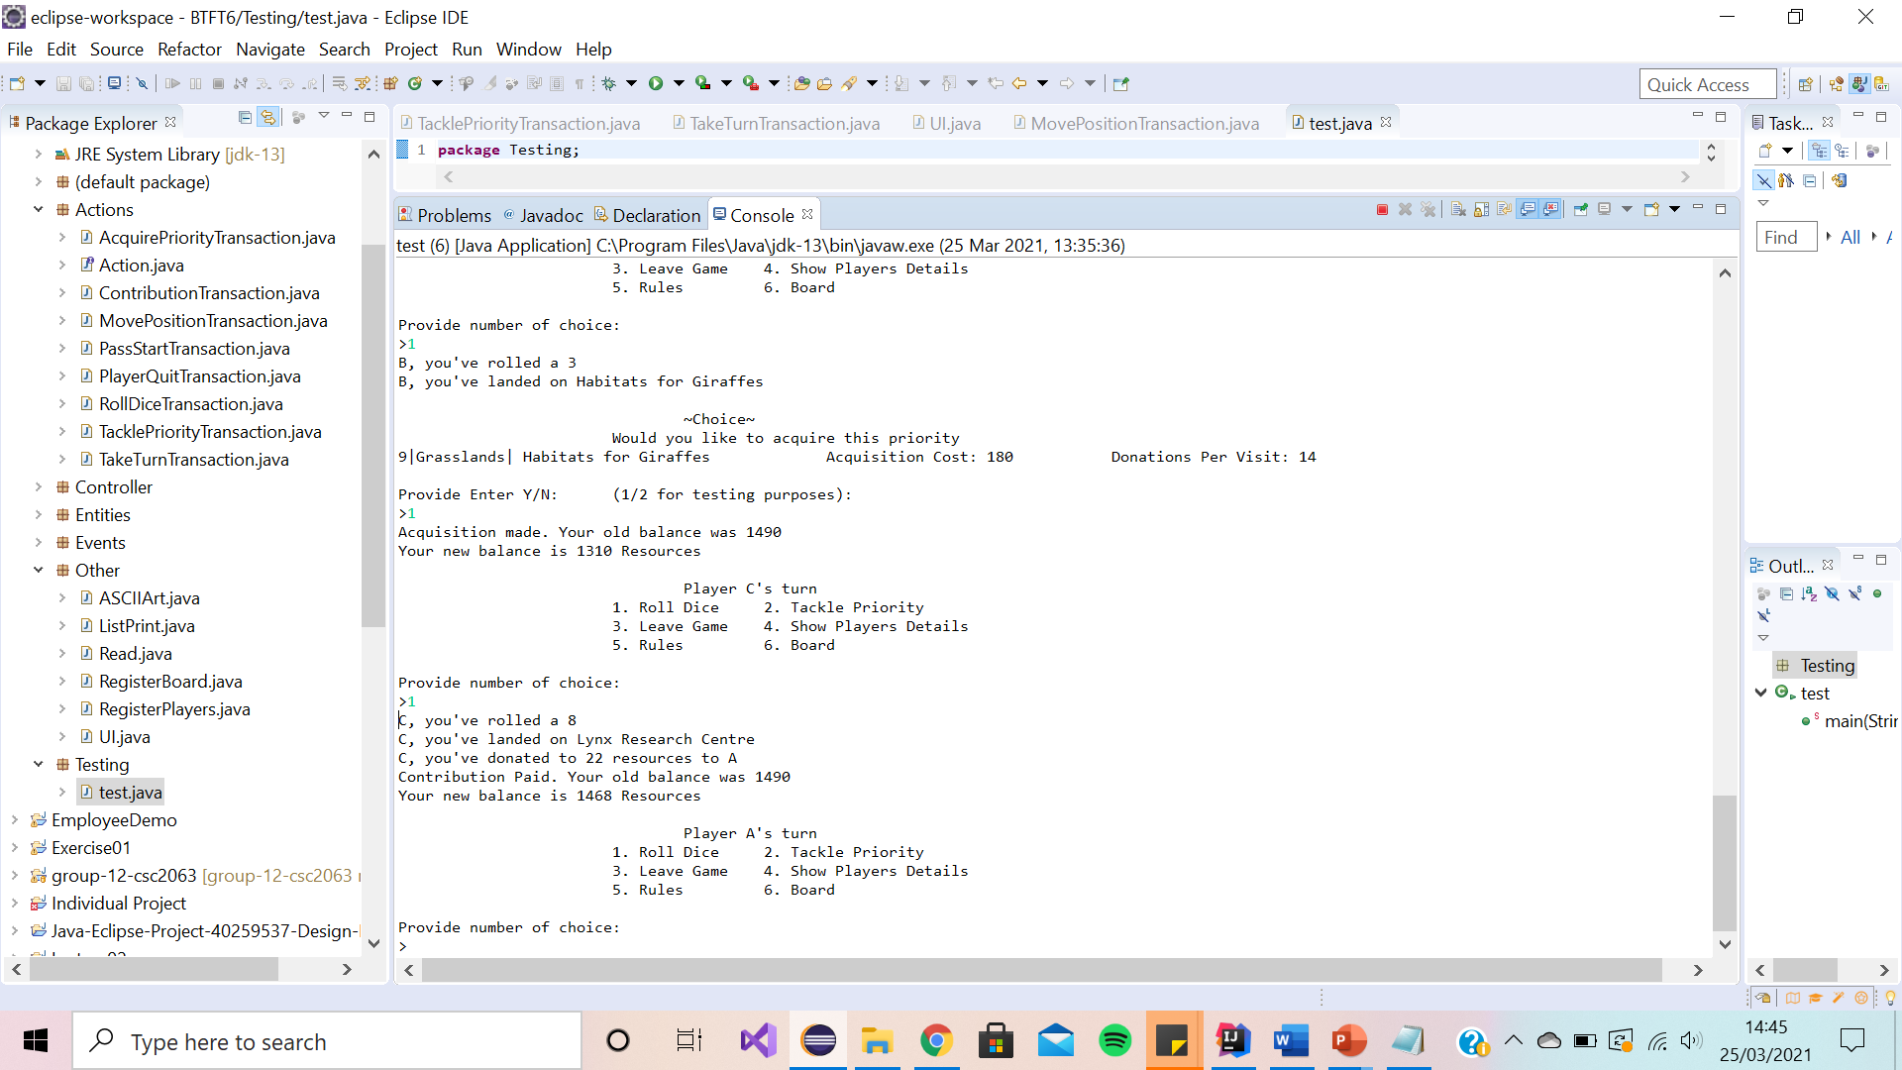

We have decided to lay the Contribution Transaction message (as shown above) as it tells the player exactly where they have landed, who they are paying and their updated resources amount. It acts as a reminder to the player, of what their resource balance is.

Ending Message

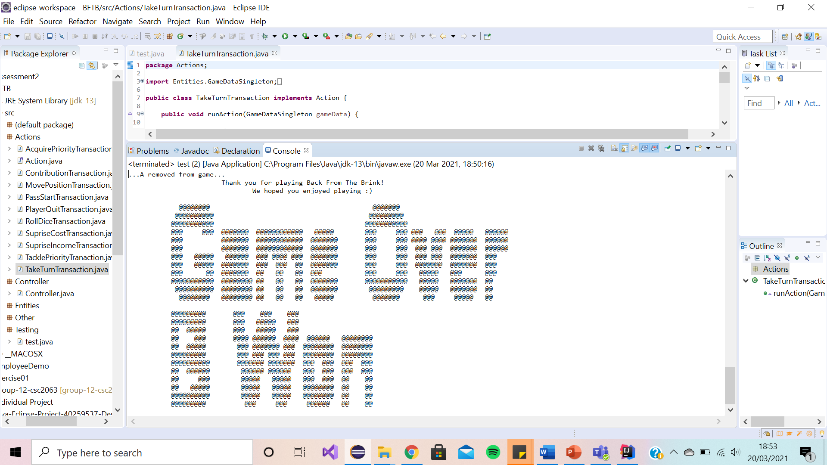

We have decided to lay the ending message (as shown above) as a print statement as it shows appreciation to the player for playing the game encouraging the player to want to play again.

**Class Relationship Model and Sequence Diagrams**

**[D.M]**

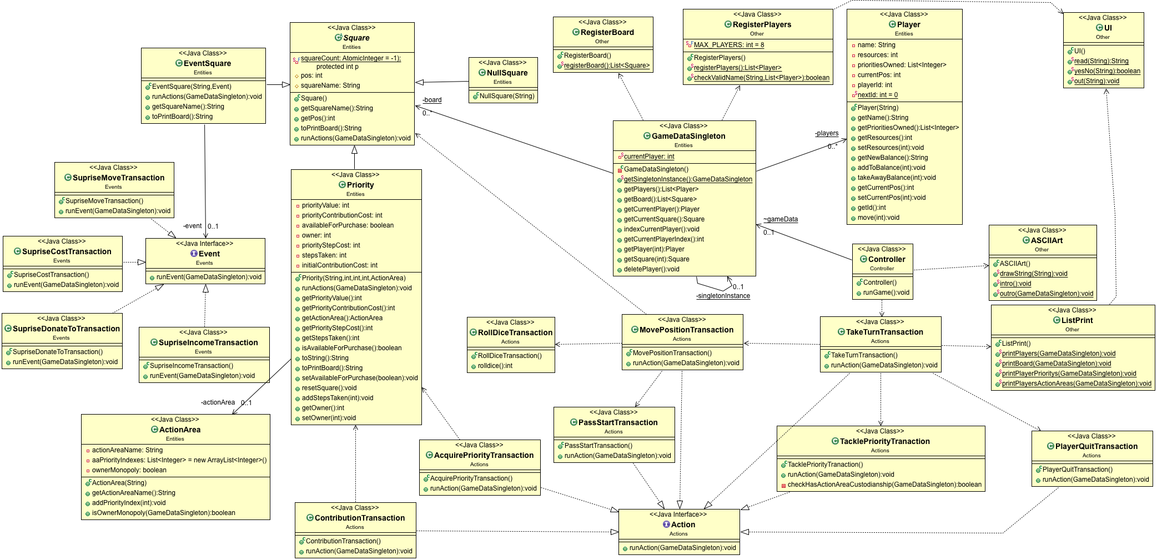

Our System has over 20 classes. The game is made up of the entities; Player, Square and GameDataSingleton. There are three types of square, each with different runActions() (of which there is 10 implementations). Actions affect the state of the players and board. GameDataSingleton stores the players and the board and instantiates these in RegisterBoard and RegisterPlayers­­­­­­­­. The game is ran by the controller which performs Player turns till only one is left. Read and ListPrint are for in/outputs.

**Run Game [D.M]**

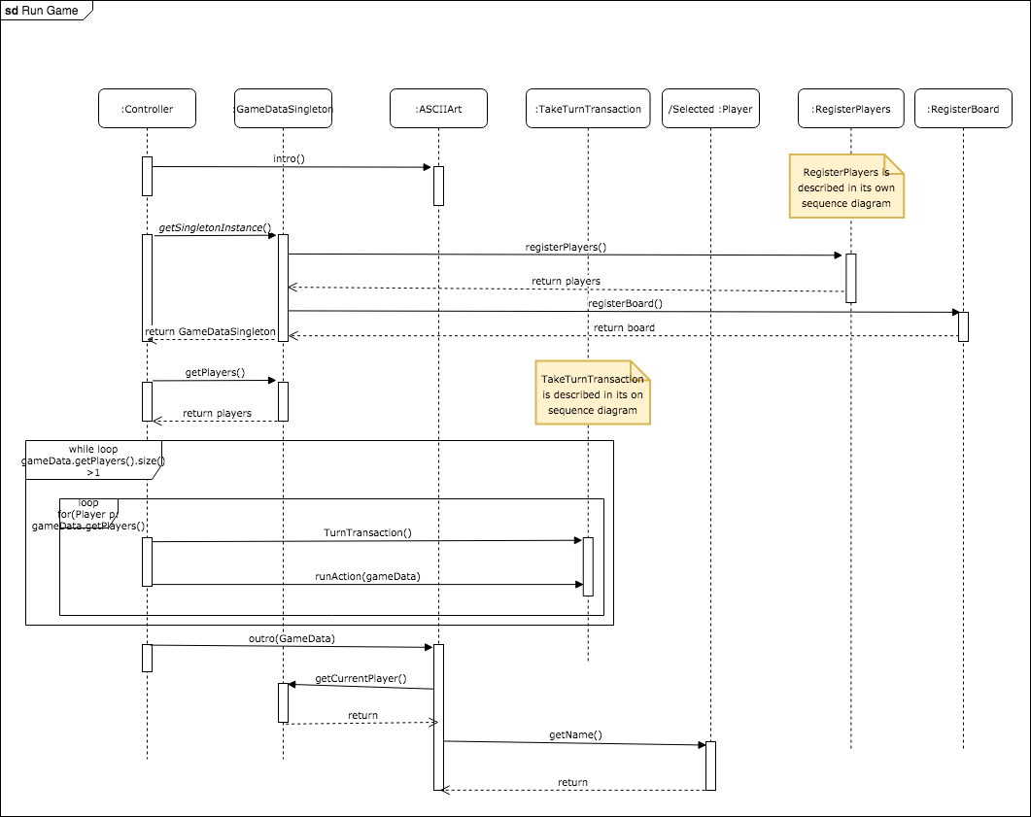

Commentary

The run game sequence diagram describes the actions the controller takes to allow the game to run

**Register Players [D.M]**

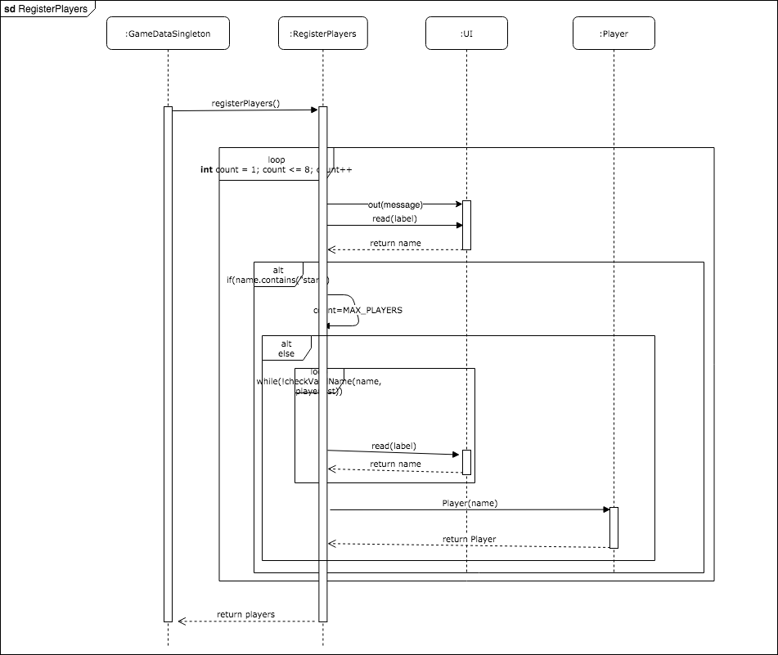

Commentary

The Register Players sequence diagram describes the program registers players and adds them to Game Data

**Take Turn [D.M]**

Commentary

The Take Turn sequence diagram describes how each player can take their turn

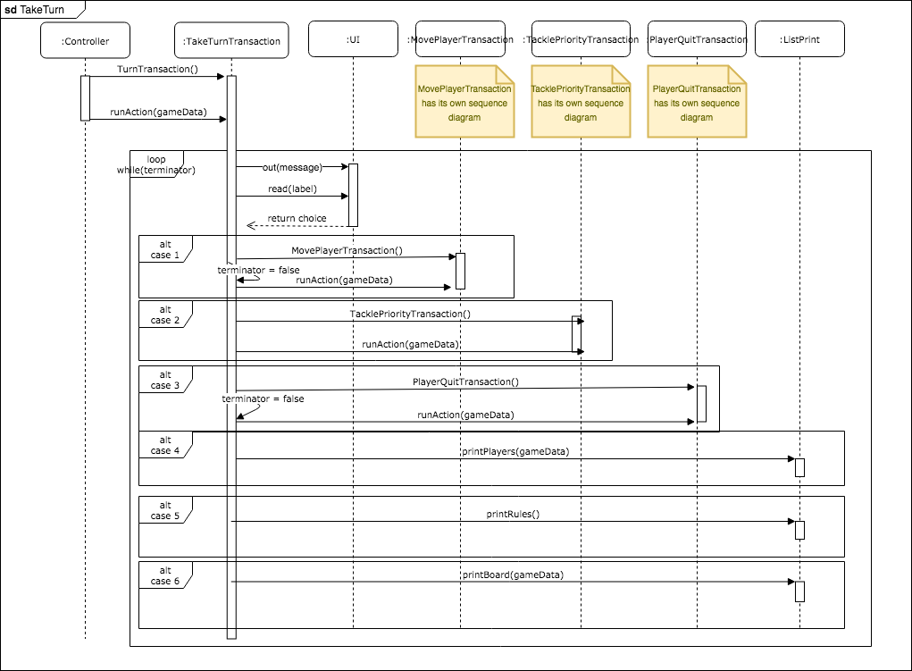

**Move Player [N.M]**

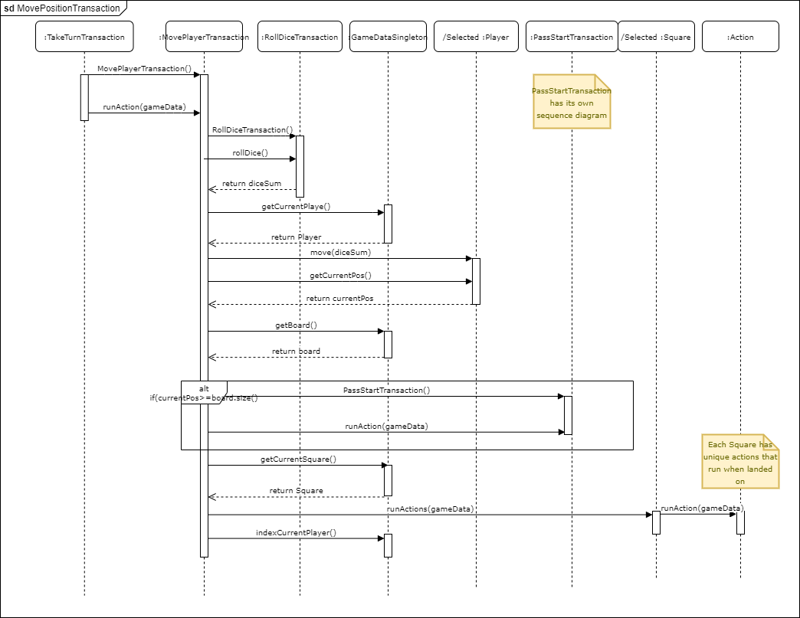

Commentary

The Move Player sequence diagram describes how the player moves­ position around the board

**Pass Start [N.M]**

Commentary

The Pass Start sequence diagram describes what happens when the player passes the starting square.

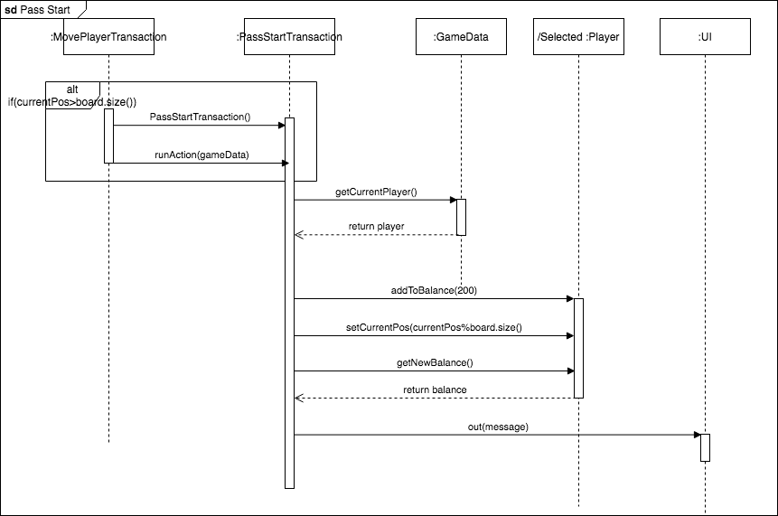

**Player Quit [N.M]**

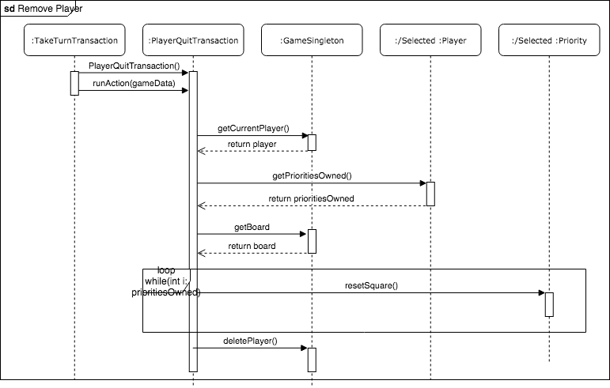

Commentary

The Player Quit sequence diagram describes how the player can remove themselves from the game during their turn

**Tackle Priority [D.M]**

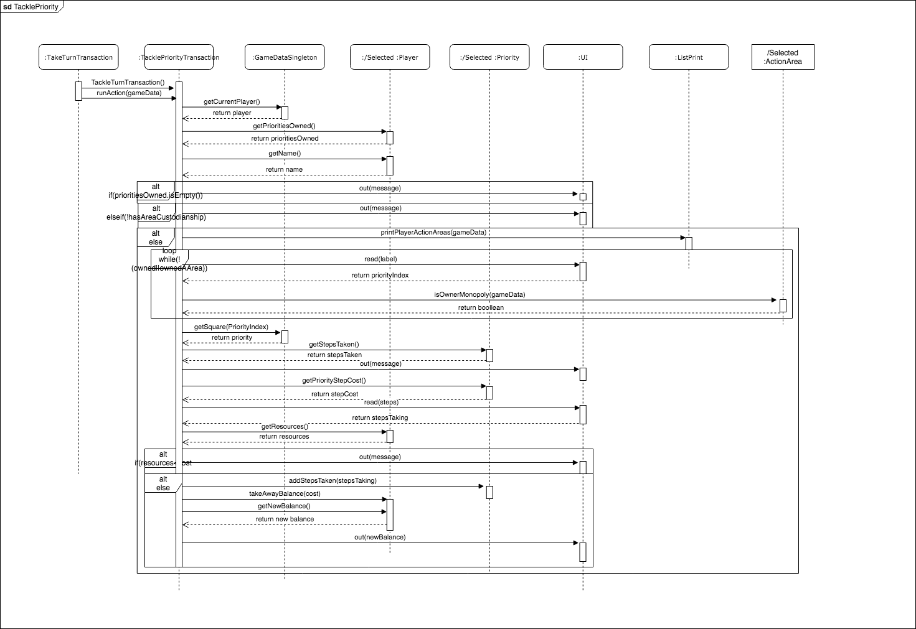

Commentary

The Tackle Priority sequence diagram describes how the player is able to select a priority they own (during their turn) and purchases upgrades for that priority

**Acquire Priority [D.M]**

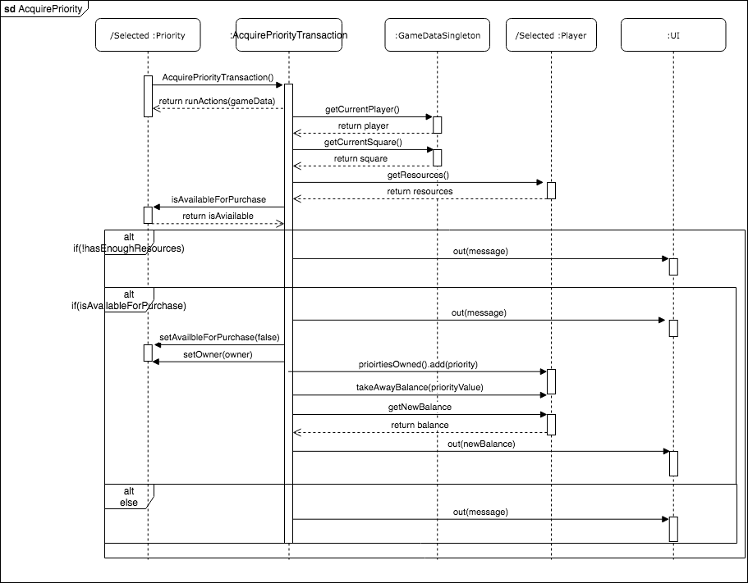

Commentary

The Acquire Priority sequence diagram describes how the player is able to purchases a priority

**Contribution [D.M]**

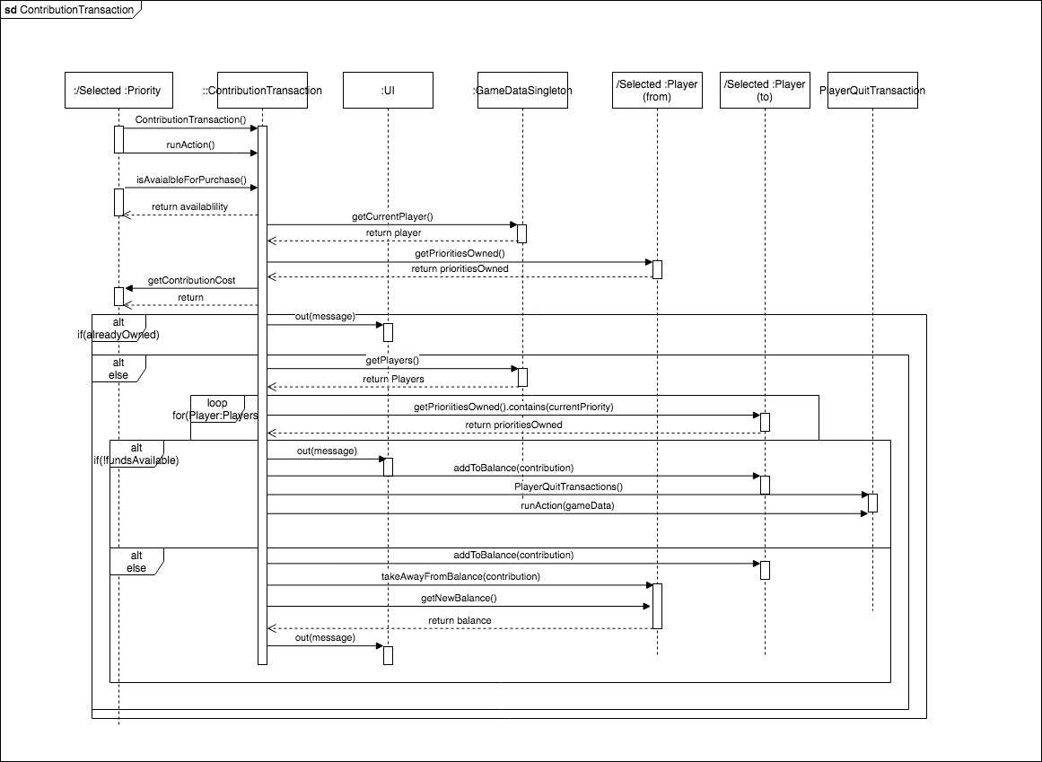

Commentary

The Contribution Transaction sequence diagram describes how the player is to pay another player whose priority they have landed on

**Final Game Layout**

**[N.M]**

|  |  |  |
| --- | --- | --- |
| **Rainforest**  (1) Jaguar Protection Centre  (2) Tapir Foundation  (3) Tamarin Trust | **Marine**  (4) Save the Crocodiles  (5) Turtle Research Centre  (6) Seahorse Conservation Centre | **Grasslands**  (7) Reserve the Rhinos  (8) Wolves Trust  (9) Habitats for Giraffes |
| **Polar Regions**  (10) Save the Penguins  (11) Seal Foundation  (12) Protection of Polar Bears  **Note: EVENT SQUARE represents ‘Added-Value Feature’ Squares** | **Mountains**  (13) Bear Foundation  (14) Lynx Research Centre  (15) Leopard Trust | **Desert**  (16) Save the Gazelles  (17) Cheetah Research  (18) Protection for Turtles |

**Action Areas**

|  |  |  |  |  |  |  |  |  |  |  |  |  |
| --- | --- | --- | --- | --- | --- | --- | --- | --- | --- | --- | --- | --- |
| **EVENT SQUARE** | **Save the Penguins** | | **Seal Foundation** | | **EVENT SQUARE** | **Protection of Polar Bears** | | **Bear Foundation** | | **Lynx Research Centre** | | **Leopard Trust** |
|  |  | |  | |  |  | |  | |  | |  |
| **Habitats for Giraffes** |  | | | | | | | | | | | **Save the Gazelles** |
|  |  |
| **Wolves Trust** | **Cheetah Research** |
|  |  |
| **Reserve the Rhinos** | **Protection for Turtles** |
|  |  |
| **EVENT SQUARE** | **EVENT SQUARE** |
|  |  |
| **Seahorse Conservation Centre** | **Turtle Research Centre** | **Save the Crocodiles** | | **Tamarin Trust** | | | **Tapir Foundation** | | **EVENT SQUARE** | | **Jaguar Protection Centre** | **START SQUARE** |
|  |  |  | |  | | |  | |  | |  | **The Edge of the World** |

|  |  |  |  |  |  |
| --- | --- | --- | --- | --- | --- |
| Square 0  “The Edge of the World” | Square 1  Colour Dark Green  “Jaguar Protection Centre” | Square 2  Colour Purple  Surprise Event. | Square 3  Colour Dark Green  “Tapir Foundation” | Square 4  Colour Dark Green  “Save the Crocodiles” | Square 5  Colour Dark Blue  “World Wildlife Trust” |
| Collect 200 Ʀ | Purchase cost 60R  Step Cost 30R  Contribution Costs:  2R  1Step(10R), 2Step(30R),  3Step(90R)  Maj Step cost 250R | Potential Events  Surprise Costs  Surprise Donation  Surprise Income  Surprise Move | Purchase cost 60R  Step Cost 30R  Contribution Costs:  4R  1Step(20R), 2Step(60R),  3Step(180R)  Maj Step cost 450R | Purchase cost 100R  Step Cost 50R  Contribution Costs:  6R  1Step(30R), 2Step(90R),  3Step(270R)  Maj Step cost 550R | Purchase cost 100R  Step Cost 50R  Contribution Costs:  6R  1Step(30R), 2Step(90R),  3Step(270R)  Maj Step cost 550R |

|  |  |  |  |  |  |
| --- | --- | --- | --- | --- | --- |
| Square 6  Colour Dark Blue  “Turtle Research Centre” | Square 7  Colour Dark Blue  “Seahorse Conservation Centre” | Square 8  Colour Purple  Surprise Event. | Square 9  Colour Green  “Sea Turtle Foundation” | Square 10  Colour Green  “Reserve the Rhinos” | Square 11  Colour Green  “Wolves Trust” |
| Purchase cost 120R  Step Cost 60R  Contribution Costs:  8R  1Step(40R), 2Step(100R),  3Step(3000R)  Maj Step cost 600R | Purchase cost 140R  Step Cost 70R  Contribution Costs:  10R  1Step(50R), 2Step(150R),  3Step(450R)  Maj Step cost  750R | Potential Events  Surprise Costs  Surprise Donation  Surprise Income  Surprise Move | Purchase cost 140R  Step Cost 70R  Contribution Costs:  10R  1Step(50R), 2Step(150R),  3Step(4500R)  Maj Step cost 750R | Purchase cost 160R  Step Cost 80R  Contribution Costs:  12R  1Step(60R), 2Step(180R),  3Step(500R)  Maj Step cost 900R | Purchase cost 180R  Step Cost 90R  Contribution Costs:  14R  1Step(70R), 2Step(200R),  3Step(550R)  Maj Step cost 950R |

|  |  |  |  |  |  |
| --- | --- | --- | --- | --- | --- |
| Square 12  Colour Green  “Habitats for Giraffes” | Square 13  Colour Purple  Surprise Event. | Square 14  Colour Blue  “Save the Penguins” | Square 15  Colour Blue  “Seal Foundation” | Square 16  Colour Purple  Surprise Event. | Square 17  Colour Blue  “Protection of Polar Bears” |
| Purchase cost 180R  Step Cost 90R  Contribution Costs:  14R  1Step(70R), 2Step(200R),  3Step(550R)  Maj Step cost 950R | Potential Events  Surprise Costs  Surprise Donation  Surprise Income  Surprise Move | Purchase cost 200R  Step Cost 100R  Contribution Costs:  16R  1Step(80R), 2Step(220R),  3Step(600R)  Maj Step cost 1000R | Purchase cost 220R  Step Cost 110R  Contribution Costs:  18R  1Step(90R), 2Step(250R),  3Step(700R)  Maj Step cost 1050R | Potential Events  Surprise Costs  Surprise Donation  Surprise Income  Surprise Move | Purchase cost 220R  Step Cost 120R  Contribution Costs:  18R  1Step(90R), 2Step(250R),  3Step(700R)  Maj Step cost 1050R |

|  |  |  |  |  |  |  |
| --- | --- | --- | --- | --- | --- | --- |
| Square 18  Colour Brown  “Bear Foundation” | Square 19  Colour Brown  “Lynx Research Centre” | Square 20  Colour Blue  “Leopard Trust” | Square 21  Colour Yellow  “Save the Gazelles” | Square 22  Colour Yellow  “Cheetah Research” | Square 23  Colour Yellow  “Protection for Turtles” | Square 24  Colour Purple  Surprise Event. |
| Purchase cost 240R  Step Cost 120R  Contribution Costs:  20R  1Step(100R), 2Step(300R),  3Step(750R)  Maj Step cost 1100R | Purchase cost 260R  Step Cost 130R  Contribution Costs:  22R  1Step(110R), 2Step(330R),  3Step(800R)  Maj Step cost 1150R | Purchase cost 280R  Step Cost 140R  Contribution Costs:  24R  1Step(120R), 2Step(360R),  3Step(850R)  Maj Step cost 1200R | Purchase cost 280R  Step Cost 140R  Contribution Costs:  24R  1Step(120R), 2Step(360R),  3Step(850R)  Maj Step cost 1200R | Purchase cost 280R  Step Cost 140R  Contribution Costs:  24R  1Step(120R), 2Step(360R),  3Step(850R)  Maj Step cost 1200R | Purchase cost 300R  Step Cost 150R  Contribution Costs:  26R  1Step(130R), 2Step(380R),  3Step(900R)  Maj Step cost 1250R | Potential Events  Surprise Costs  Surprise Donation  Surprise Income  Surprise Move |

**Implementation-Related Documentation**

**Test Plan**

**[N.M]**

**Test Acceptance**

We have tested all key elements of system functionality through acceptance testing and Junit testing. Shown below is a sample of our acceptance test document.

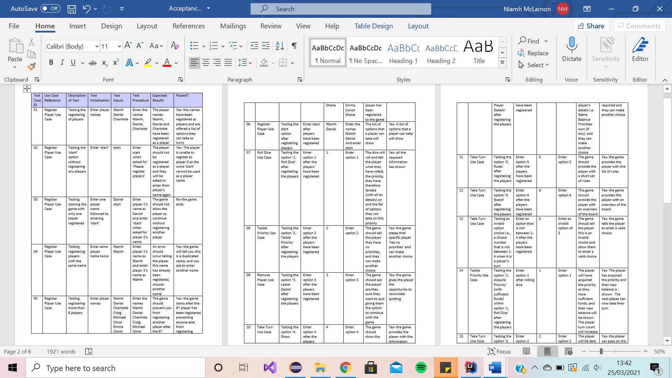



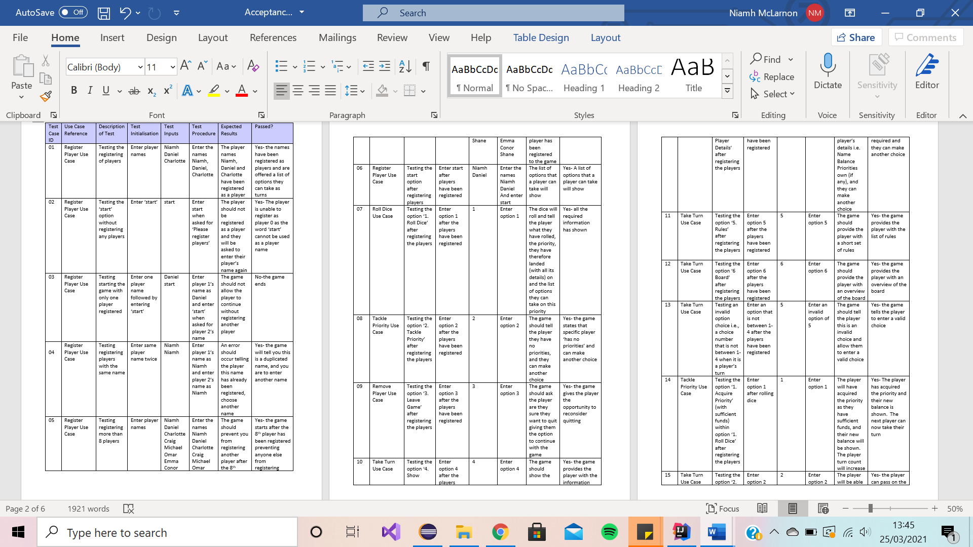

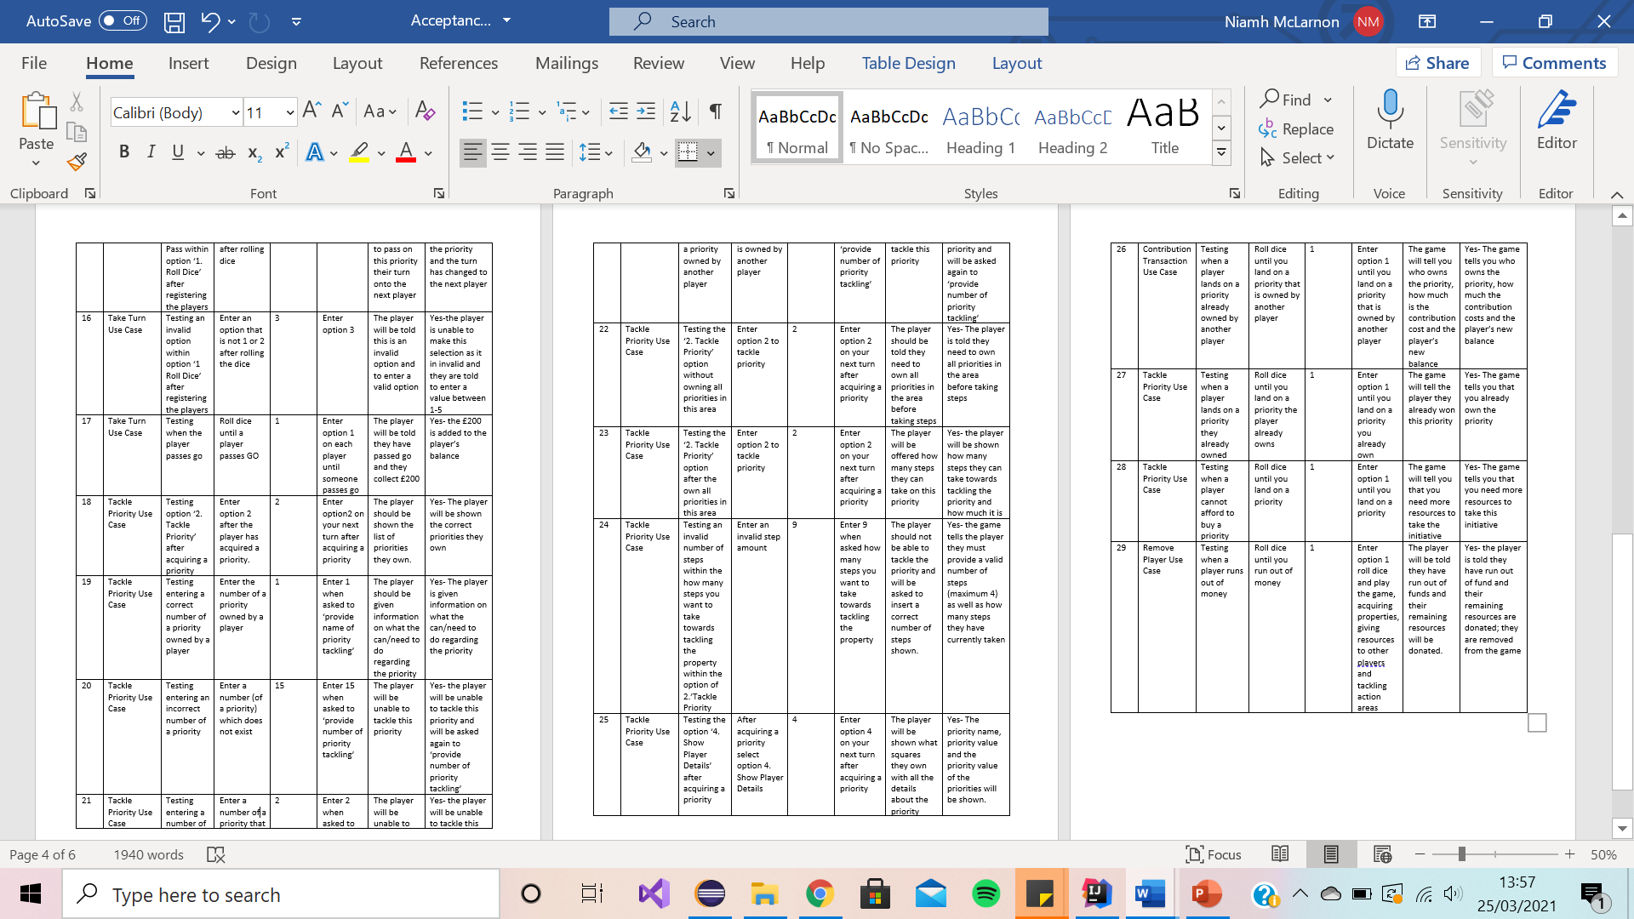

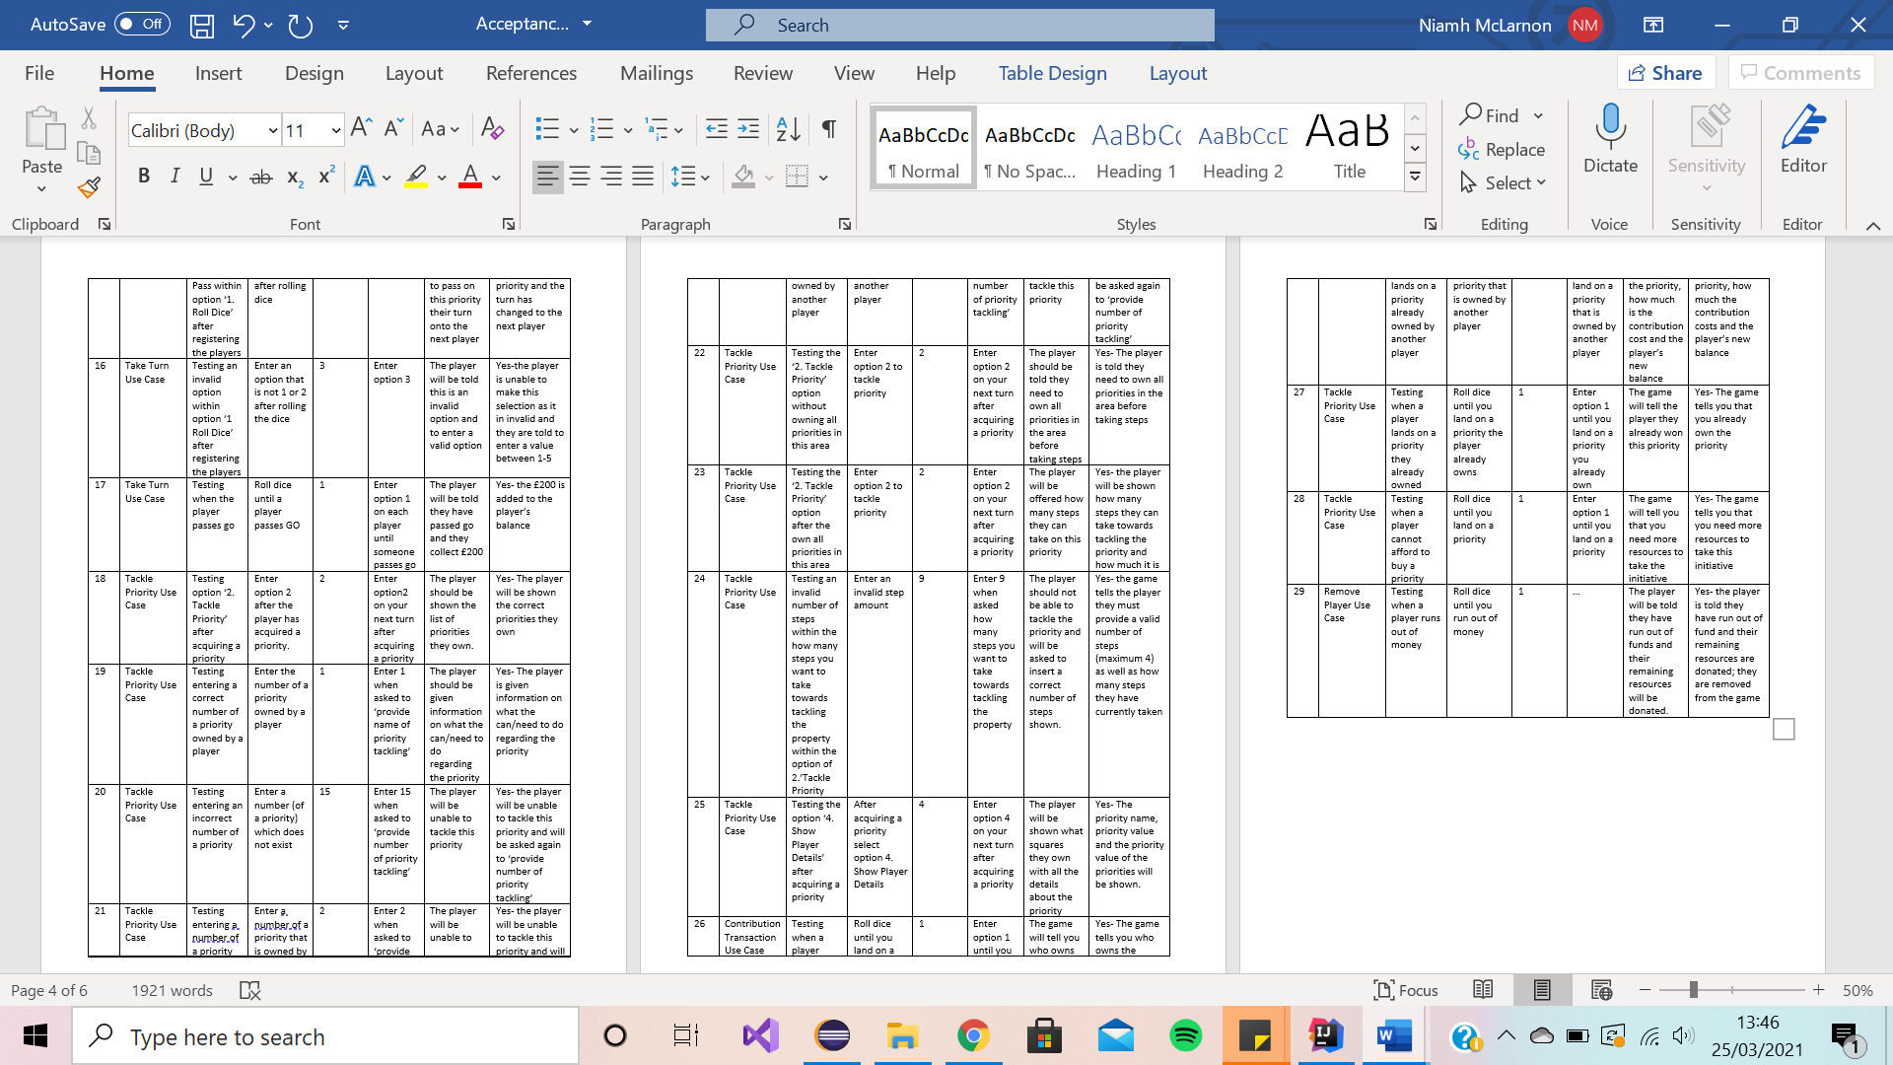

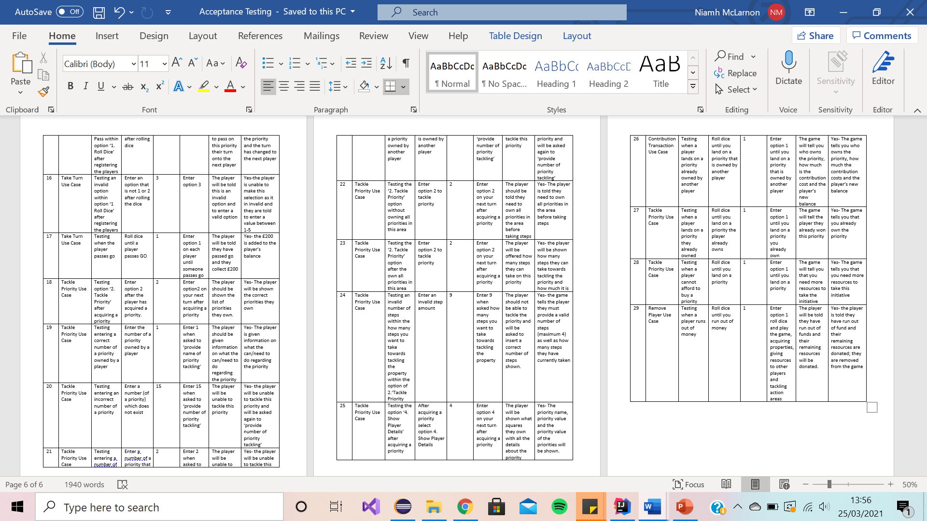

**Junit Testing**

**[N.M; D.M]**

Shown below are some sample screenshots of our Junit testing.

**ActionArea Junit Test**

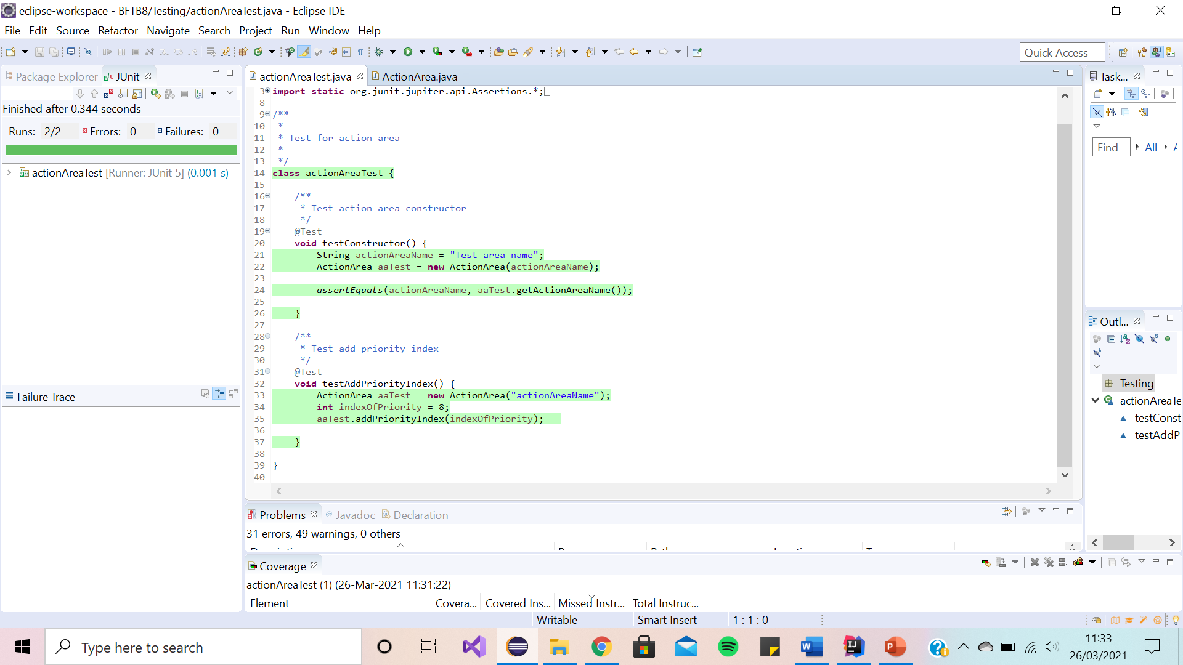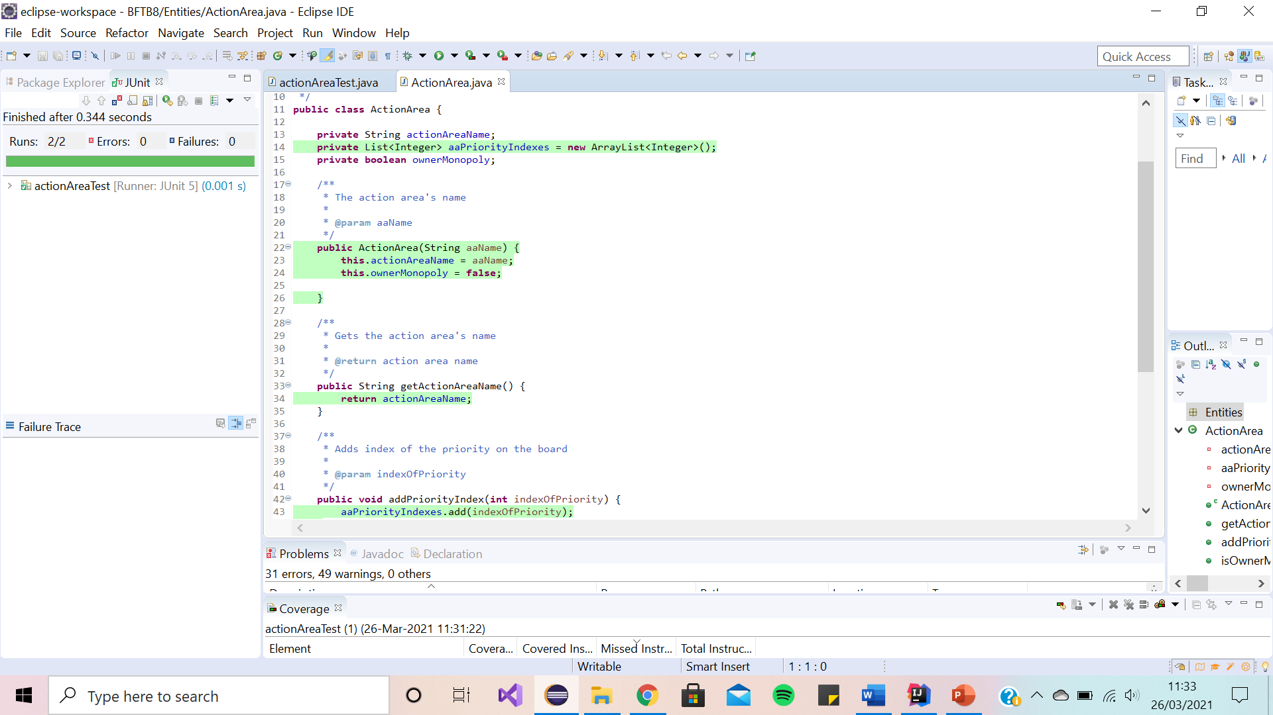

**EventSquare Junit Test**

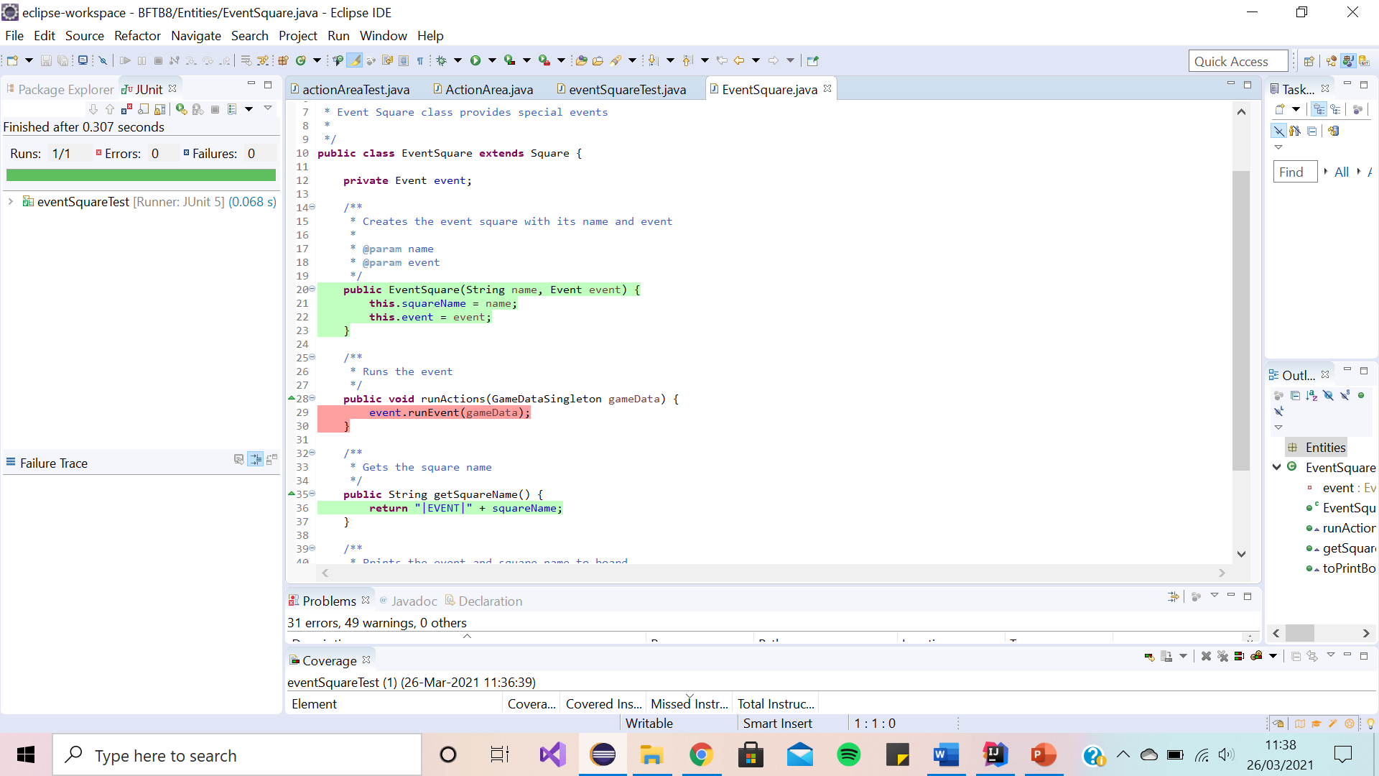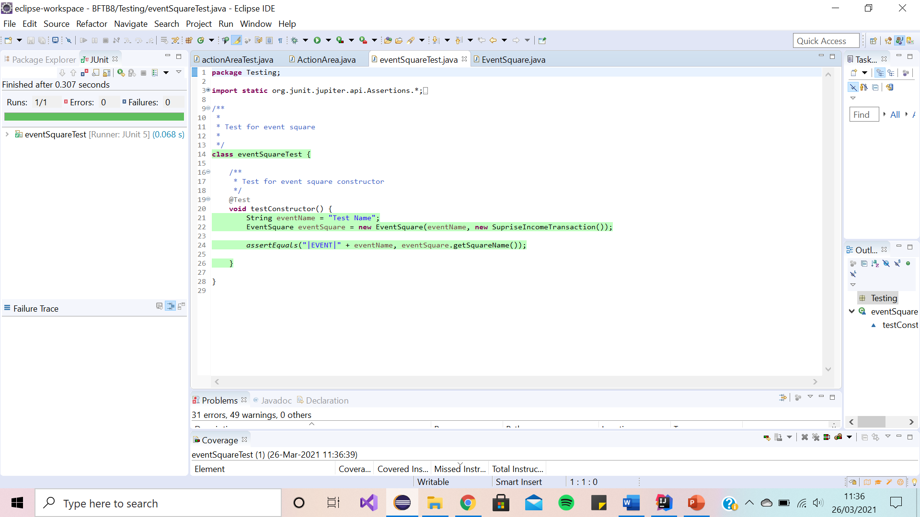

**NullSquare Junit Test**

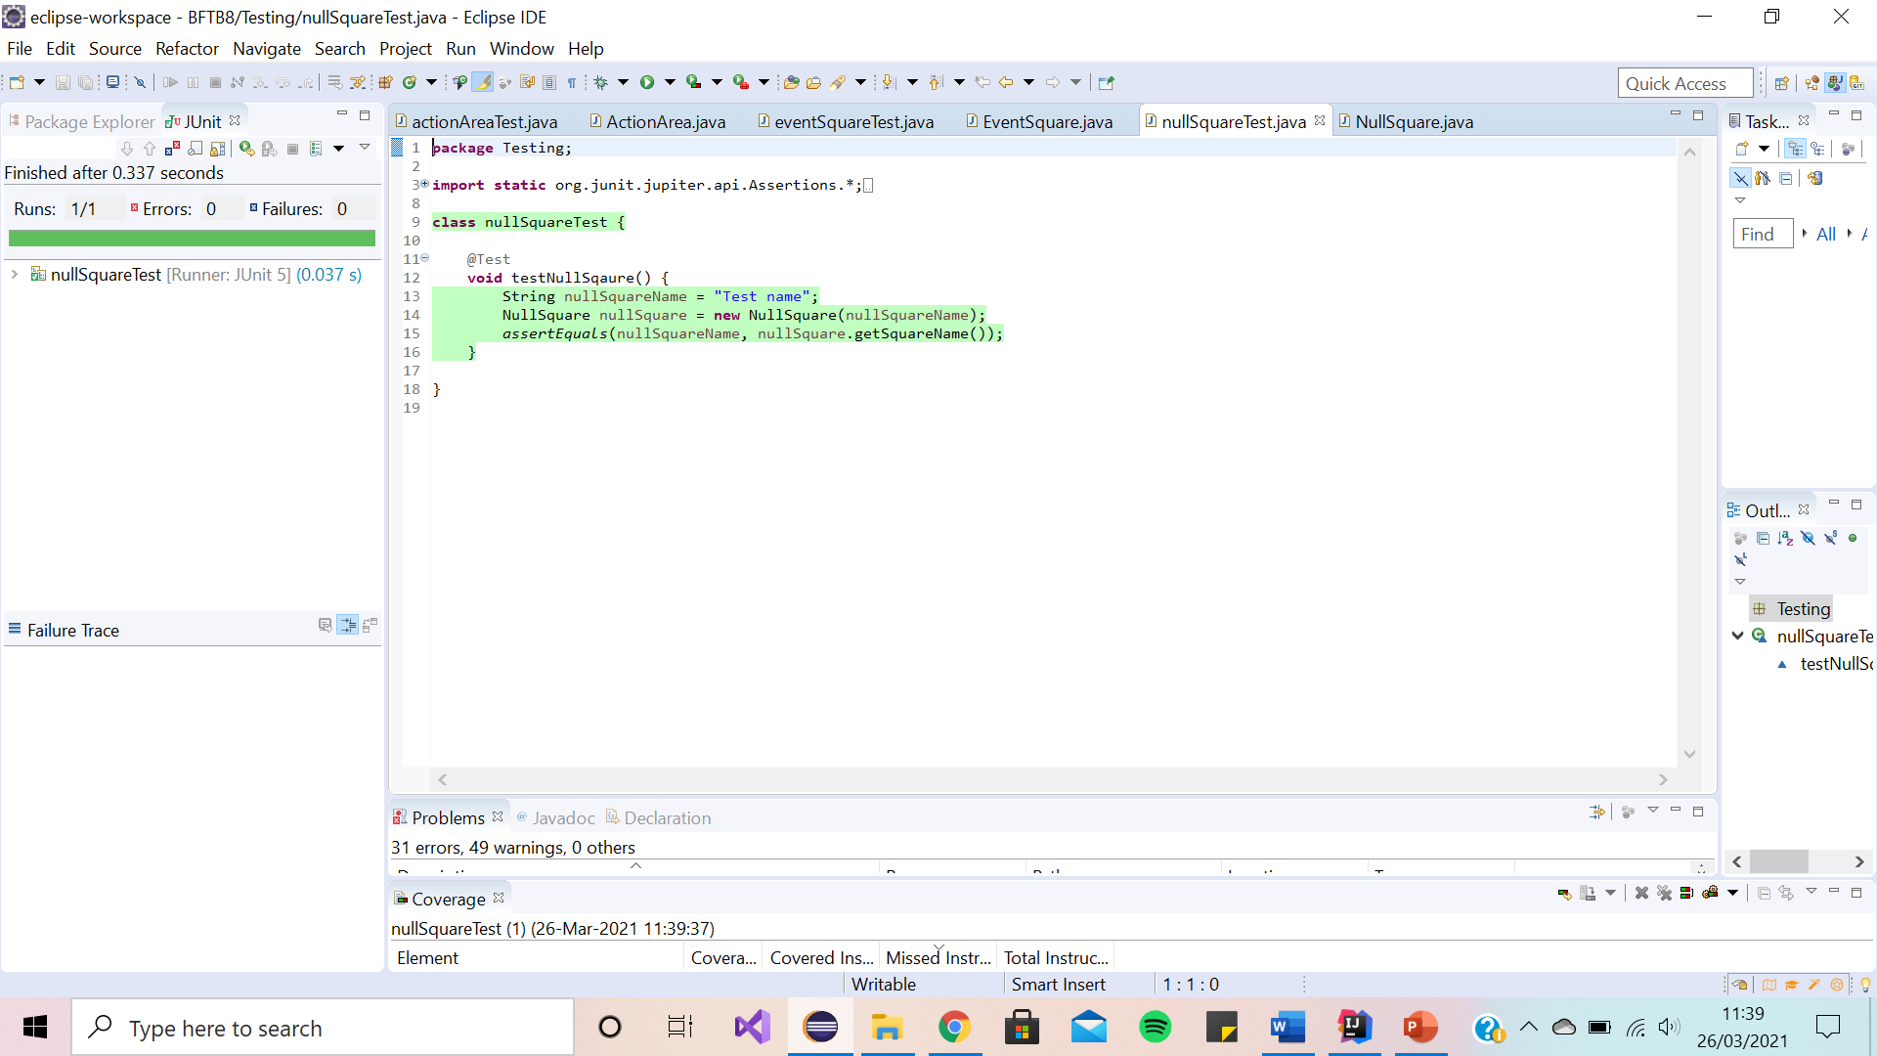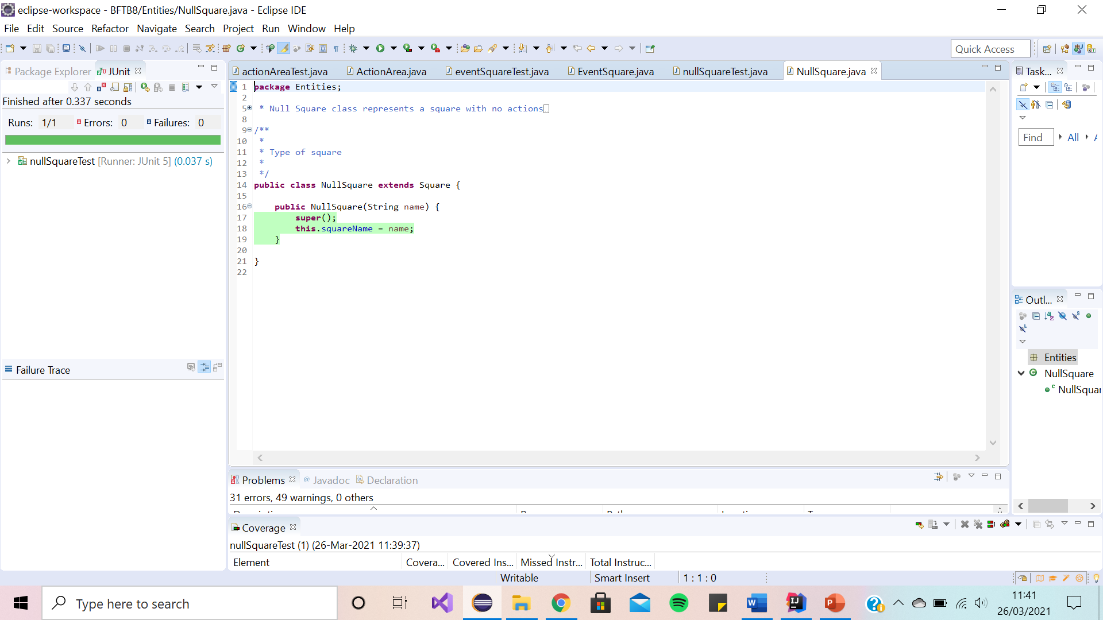

**Player Junit Test**

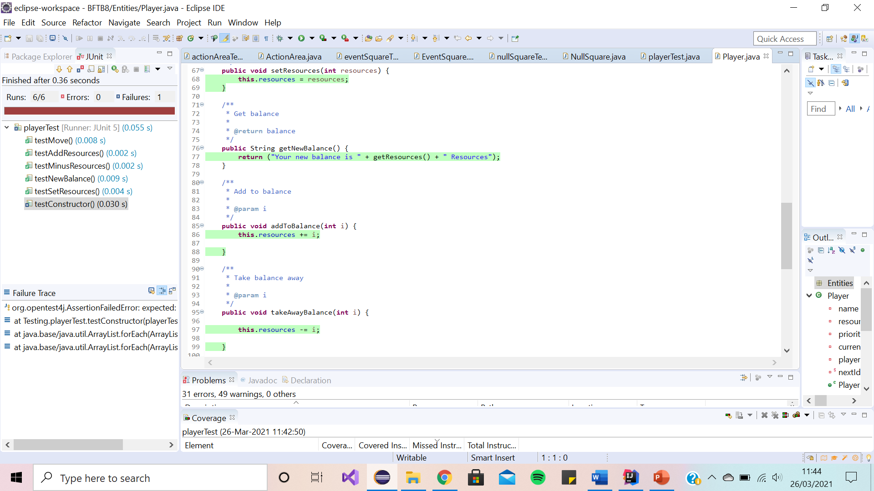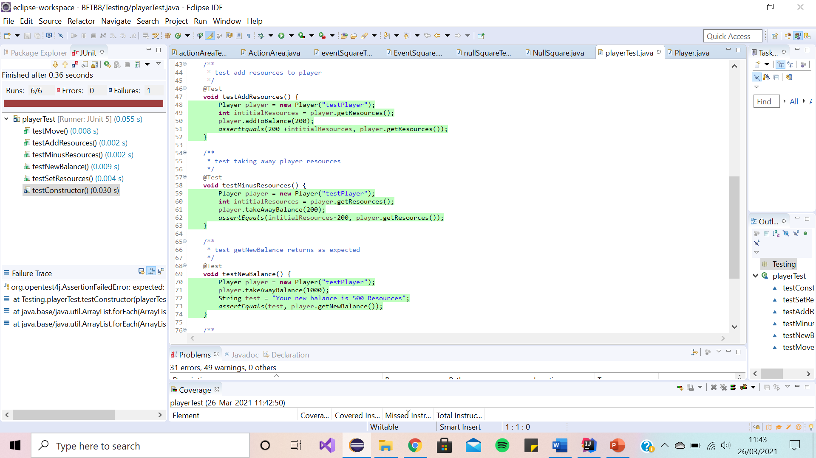

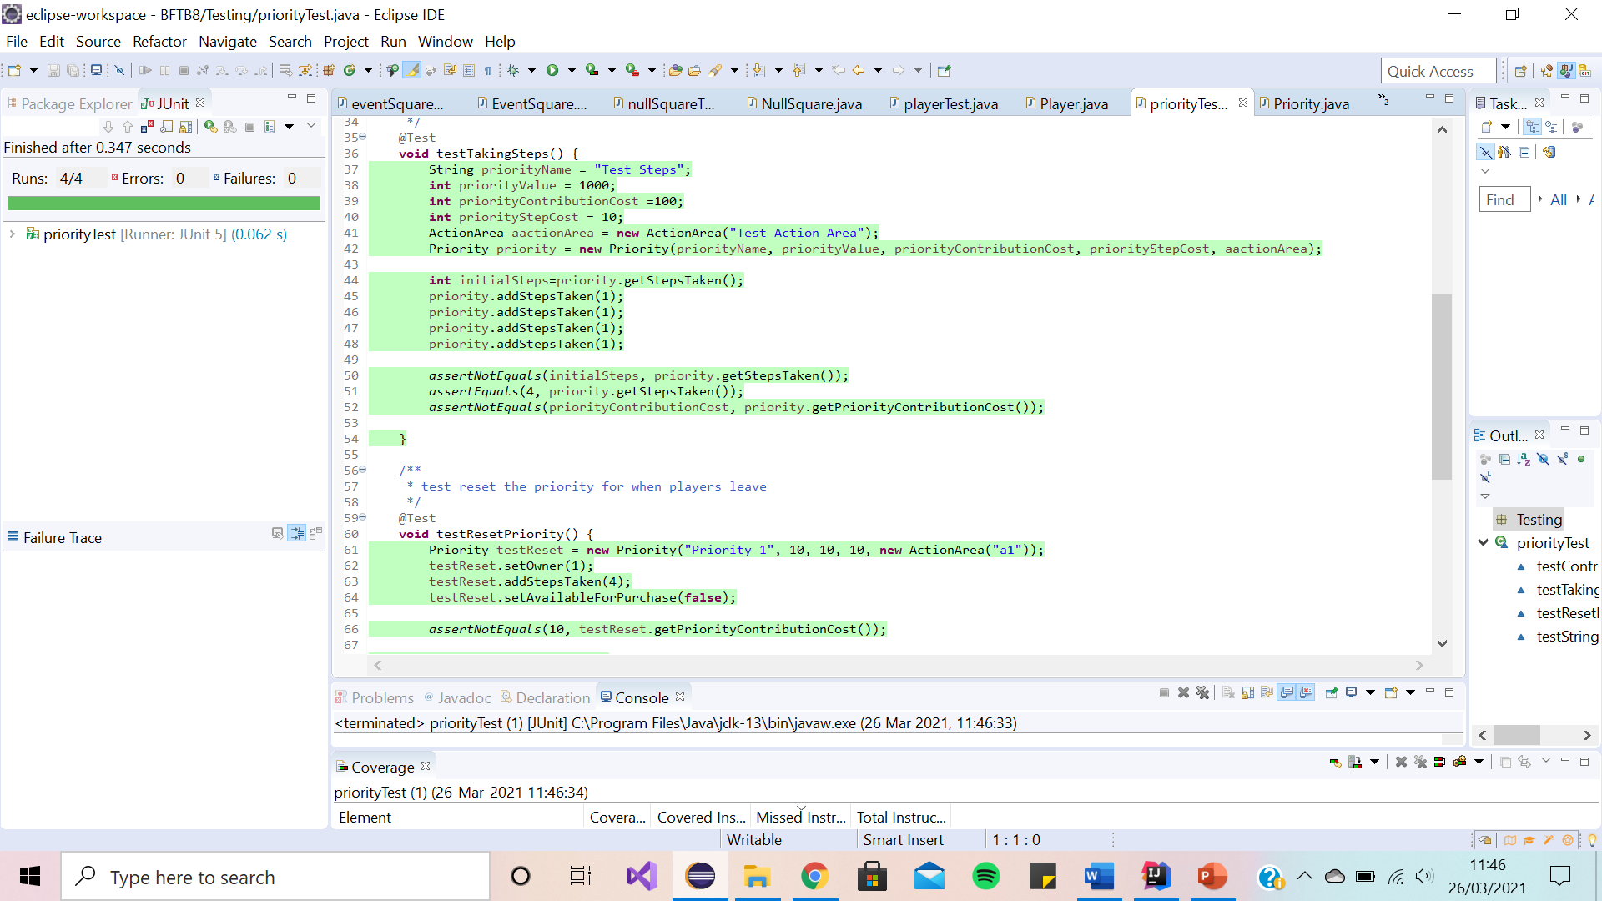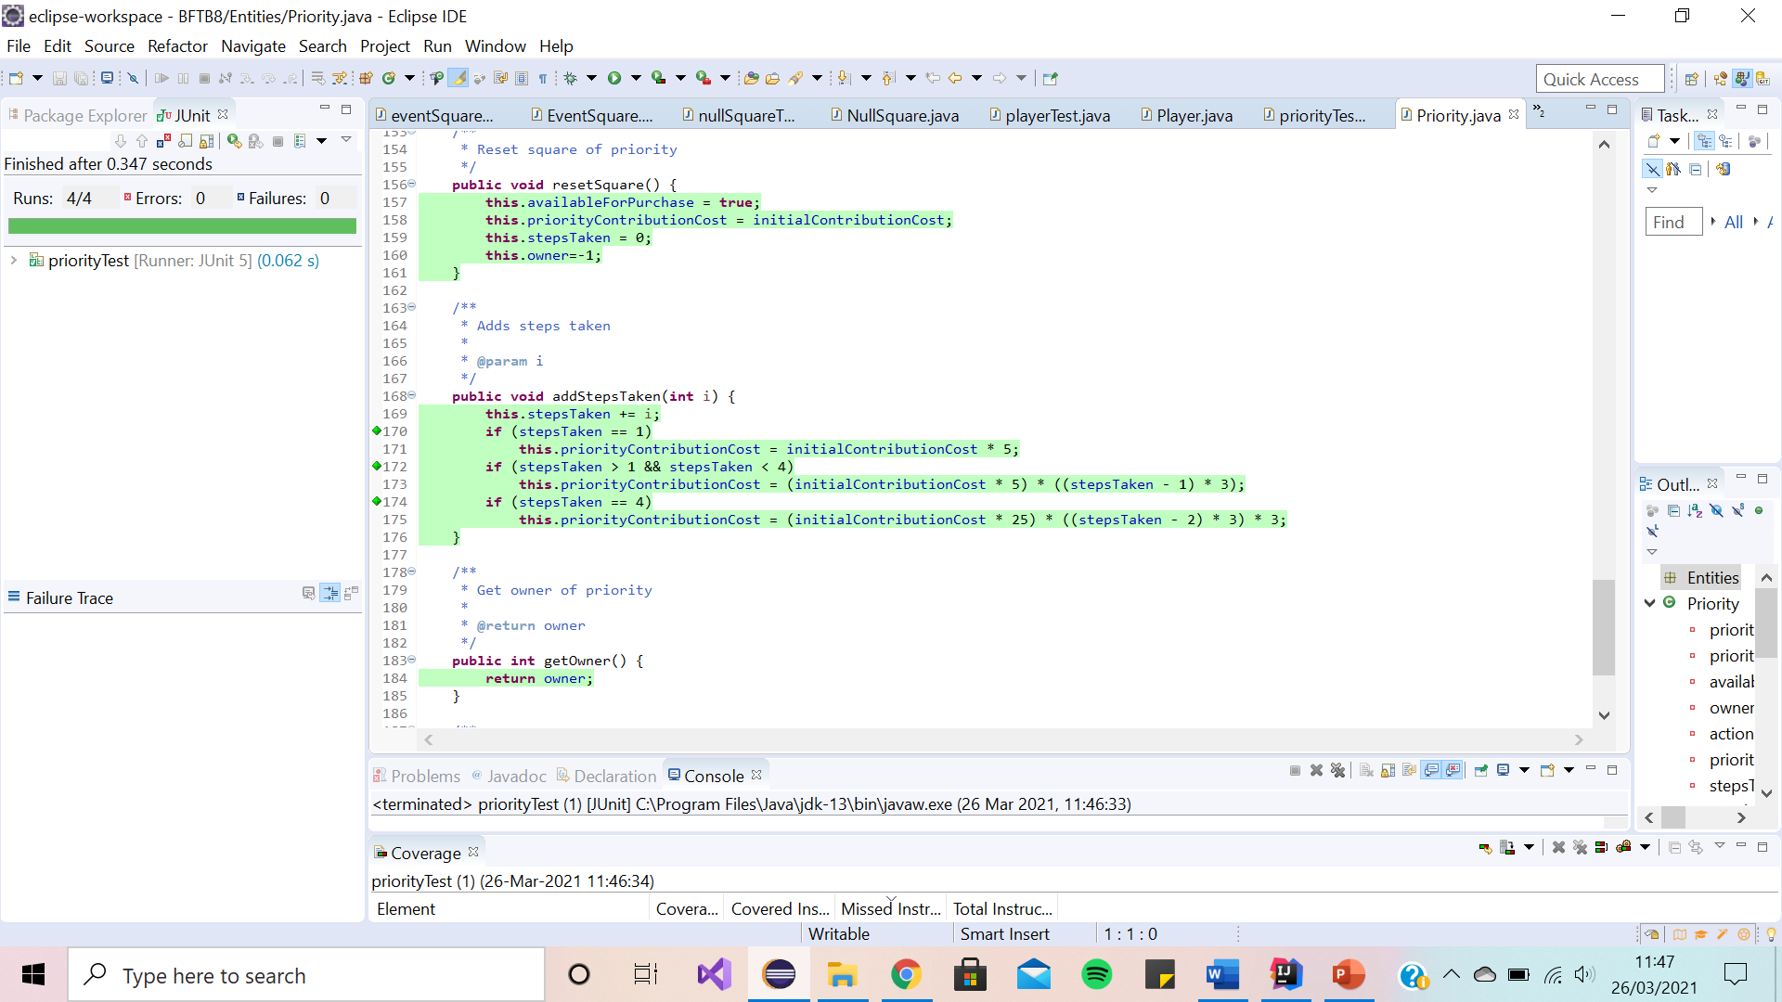**Priority Junit Test**

**Appendix**

**Adherence to Process**

(Submission 2 Team Meetings)

# Minutes for CSC2058 Project: 25 Minutes Week commencing: 22/3/2021

# Date of this minute­­­­­: 26/3/2021

The following team members were present on Teams (if not Teams, indicate platform) when minutes were discussed:

|  |  |
| --- | --- |
| Name (printed/typed) | Signature (agreed bitmap or initials) |
| Daniel Mason | DM |
| Niamh McLarnon | NML |
| Craig Mulligan | CM |
| Michael Kennedy | MK |
| Omar Ahmed Hassan Abdelfattah Bashah | OB |
| Charlotte Bisp | CB |

Task Reporting (Briefly list the progress for each team member in the last week.*)

**PEER REVIEW**

Name (Daniel):

* Completed code
* Completed class diagram
* Completed sequence diagrams
* Completed Junit testing

Name (Niamh):

* Completed text user interface
* Completed testing
* Completed Junit testing
* Completed pdf report

Name (Craig):

* Attended peer review
* Checked over gitlab

Name (Michael):

* Attended peer review
* Checked over gitlab

Name (Omar):

* Attended peer review
* Checked over gitlab

Name (Charlotte):

* Attended peer review
* Checked over gitlab

Actions Planned (Briefly list the actions required of each team member for the next week.)

Name (Daniel):

* Create demo video
* Submit demo video
* Submit code

Name (Niamh):

* Submit pdf

Name (Craig):

Name (Michael):

Name (Omar):

Name (Charlotte):

**Minutes for CSC2058 Project:** 25 Minutes **Week commencing:** 25/1/2021

**Date of this minute­­­­­:** 25/1/2021

The following team members were present on Teams (if not Teams, indicate platform) when minutes were discussed:

|  |  |
| --- | --- |
| Name (printed/typed) | Signature (agreed bitmap or initials) |
| Daniel Mason | DM |
| Niamh McLarnon | NML |
| Craig Mulligan | CM |
| Michael Kennedy | MK |
| Omar Ahmed Hassan Abdelfattah Bashah | OB |
| Charlotte Bisp | CB |

Task Reporting (Briefly list the progress for each team member in the last week.*)

Name (Daniel):

* Reviewed Feedback for Submission 1
* Video call meeting with Ian to review submission 1

Name (Niamh):

* Contacted Ian for video call feedback on Submission 1 feedback
* Reviewed feedback for Submission 1
* Video call meeting with Ian to review submission 1

Name (Craig):

Name (Michael):

Name (Omar):

Name (Charlotte):

Actions Planned (Briefly list the actions required of each team member for the next week.)

Name (Daniel):

* Draft layout for Final PDF report

Name (Niamh):

* Planned timetable for completing submission 2 deliverables

Name (Craig):

Name (Michael):

Name (Omar):

Name (Charlotte):

**Minutes for CSC2058 Project:** 25 Minutes **Week commencing:** 1/2/2021

**Date of this minute­­­­­:** 1/2/2021

The following team members were present on Teams (if not Teams, indicate platform) when minutes were discussed:

|  |  |
| --- | --- |
| Name (printed/typed) | Signature (agreed bitmap or initials) |
| Daniel Mason | DM |
| Niamh McLarnon | NML |
| Craig Mulligan | CM |
| Michael Kennedy | MK |
| Omar Ahmed Hassan Abdelfattah Bashah | OB |
| Charlotte Bisp | CB |

Task Reporting (Briefly list the progress for each team member in the last week.*)

Name (Daniel):

* Created pdf file for finale report

Name (Niamh):

* Went over code and spec and made notes on what needs done for submission 2

Name (Craig):

Name (Michael):

Name (Omar):

Name (Charlotte):

Actions Planned (Briefly list the actions required of each team member for the next week.)

Name (Daniel):

* Look at what needs to be done on code for submission 2
* Cleaned Repository

Name (Niamh):

* Plan what value-added features there will be
* Created template for testing

Name (Craig):

Name (Michael):

Name (Omar):

Name (Charlotte):

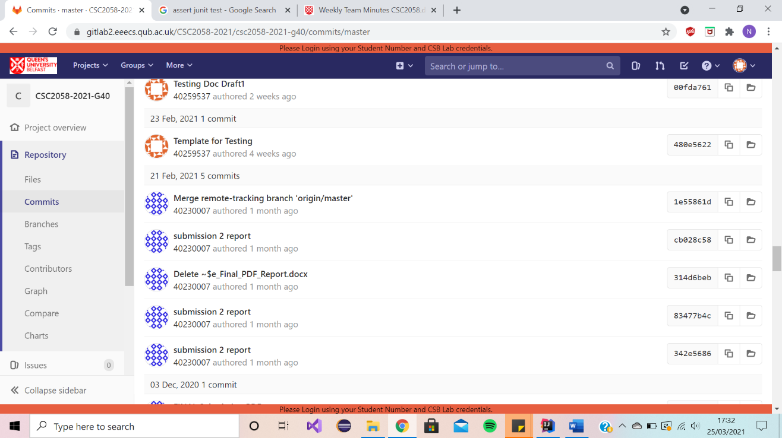

* **Minutes for CSC2058 Project:** 25 Minutes **Week commencing:** 8/2/2021
* **Date of this minute­­­­­:** N/A

Task Reporting (Briefly list the progress for each team member in the last week.*)

Name (Daniel):

* Continued to work on code

Name (Niamh):

* Started test plan

Name (Craig):

Name (Michael):

Name (Omar):

Name (Charlotte):

N/A no meeting this week

**Minutes for CSC2058 Project:** 25 Minutes **Week commencing:** 15/2/2021

**Date of this minute­­­­­:** 15/2/2021

The following team members were present on Teams (if not Teams, indicate platform) when minutes were discussed:

|  |  |
| --- | --- |
| Name (printed/typed) | Signature (agreed bitmap or initials) |
| Daniel Mason | DM |
| Niamh McLarnon | NML |
| Craig Mulligan | CM |
| Michael Kennedy | MK |
| Omar Ahmed Hassan Abdelfattah Bashah | OB |
| Charlotte Bisp | CB |

Task Reporting (Briefly list the progress for each team member in the last week.*)

Name (Daniel):

* Worked on code (add more of the basic functionalities, close to completing all basic functionalities)

Name (Niamh):

* Started working on testing documentation
* Minor updates to code

Name (Craig):

Name (Michael):

Name (Omar):

Name (Charlotte):

Actions Planned (Briefly list the actions required of each team member for the next week.)

Name (Daniel):

* Finish basic functionalities of code
* Make action areas work

Name (Niamh):

* Start Text user interface
* Continue on testing documentation

Name (Craig):

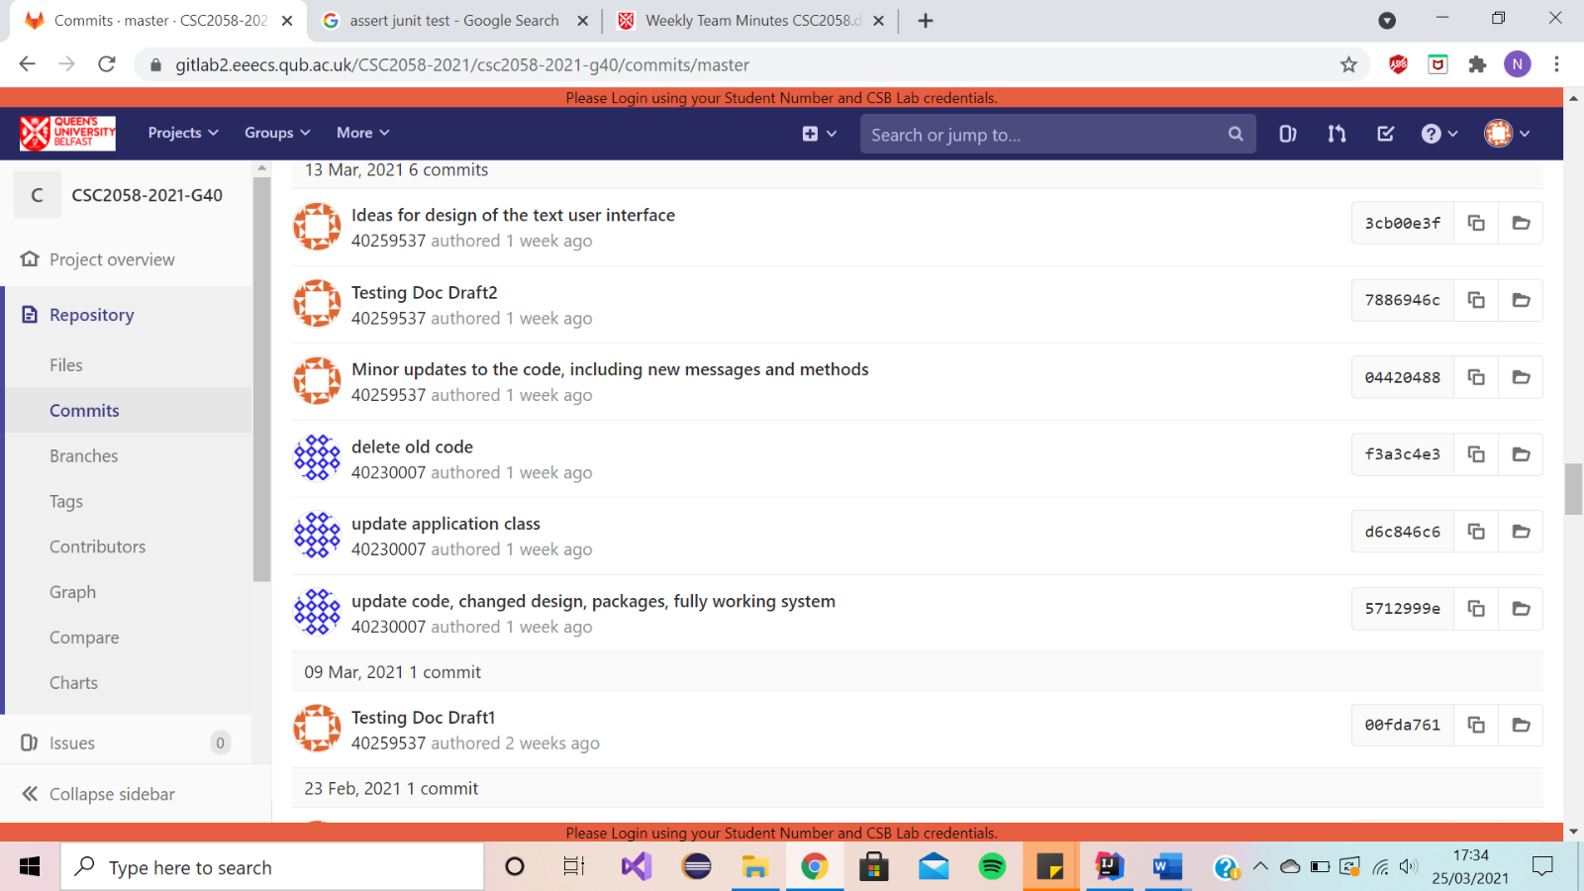

Name (Michael):

Name (Omar):

Name (Charlotte):

* **Minutes for CSC2058 Project:** 25 Minutes **Week commencing:** 22/2/2021
* **Date of this minute­­­­­:** 22/2/2021

The following team members were present on Teams (if not Teams, indicate platform) when minutes were discussed:

|  |  |
| --- | --- |
| Name (printed/typed) | Signature (agreed bitmap or initials) |
| Daniel Mason | DM |
| Niamh McLarnon | NML |
| Craig Mulligan | CM |
| Michael Kennedy | MK |
| Omar Ahmed Hassan Abdelfattah Bashah | OB |
| Charlotte Bisp | CB |

Task Reporting (Briefly list the progress for each team member in the last week.*)

Name (Daniel):

* Worked on the working system

Name (Niamh):

* Continued to work on testing

Name (Craig):

Name (Michael):

Name (Omar):

Name (Charlotte):

Actions Planned (Briefly list the actions required of each team member for the next week.)

Name (Daniel):

* Continue code

Name (Niamh):

* Continue to work on testing

Name (Craig):

Name (Michael):

Name (Omar):

Name (Charlotte):

* **Minutes for CSC2058 Project:** 25 Minutes **Week commencing:** 1/3/2021
* **Date of this minute­­­­­:** 1/3/2021

The following team members were present on Teams (if not Teams, indicate platform) when minutes were discussed:

|  |  |
| --- | --- |
| Name (printed/typed) | Signature (agreed bitmap or initials) |
| Daniel Mason | DM |
| Niamh McLarnon | NML |
| Craig Mulligan | CM |
| Michael Kennedy | MK |
| Omar Ahmed Hassan Abdelfattah Bashah | OB |
| Charlotte Bisp | CB |

Task Reporting (Briefly list the progress for each team member in the last week.*)

Name (Daniel):

* Worked on code
* Cleaned repository

Name (Niamh):

* Worked on testing and text user interface

Name (Craig):

Name (Michael):

Name (Omar):

Name (Charlotte):

Actions Planned (Briefly list the actions required of each team member for the next week.)

Name (Daniel):

* Continue to work on code

Name (Niamh):

* Continue working on testing

Name (Craig):

Name (Michael):

Name (Omar):

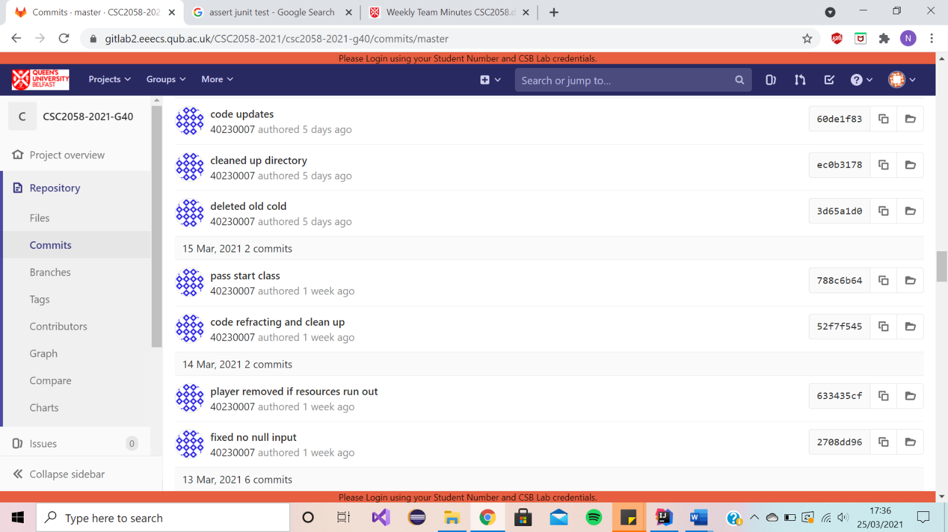

Name (Charlotte):

**Minutes for CSC2058 Project:** 25 Minutes **Week commencing:** 8/3/2021

**Date of this minute­­­­­:** 8/3/2021

The following team members were present on Teams (if not Teams, indicate platform) when minutes were discussed:

|  |  |
| --- | --- |
| Name (printed/typed) | Signature (agreed bitmap or initials) |
| Daniel Mason | DM |
| Niamh McLarnon | NML |
| Craig Mulligan | CM |
| Michael Kennedy | MK |
| Omar Ahmed Hassan Abdelfattah Bashah | OB |
| Charlotte Bisp | CB |

Task Reporting (Briefly list the progress for each team member in the last week.*)

Name (Daniel):

* Worked on code
* Applied SOLID to code
* Updated PDF document

Name (Niamh):

* Uploaded more testing
* Updated Game Layout

Name (Craig):

Name (Michael):

Name (Omar):

Name (Charlotte):

Actions Planned (Briefly list the actions required of each team member for the next week.)

Name (Daniel):

* Continue to work on code

Name (Niamh):

* Continue to work testing
* Work on code

Name (Craig):

Name (Michael):

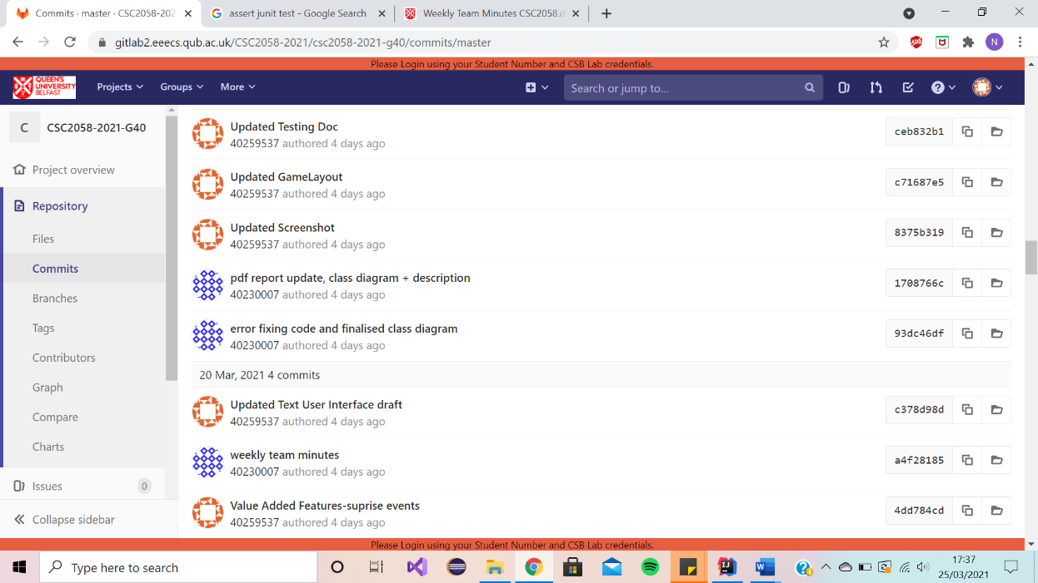

Name (Omar):

Name (Charlotte):

**Minutes for CSC2058 Project:** 25 Minutes **Week commencing:** 15/3/2021

**Date of this minute­­­­­:** 15/3/2021

The following team members were present on Teams (if not Teams, indicate platform) when minutes were discussed:

|  |  |
| --- | --- |
| Name (printed/typed) | Signature (agreed bitmap or initials) |
| Daniel Mason | DM |
| Niamh McLarnon | NML |
| Craig Mulligan | CM |
| Michael Kennedy | MK |
| Omar Ahmed Hassan Abdelfattah Bashah | OB |
| Charlotte Bisp | CB |

Task Reporting (Briefly list the progress for each team member in the last week.*)

Name (Daniel):

* Started class diagram
* Started use case realisations

Name (Niamh):

* Worked on text user interface
* Worked on testing

Name (Craig):

Name (Michael):

Name (Omar):

Name (Charlotte):

Actions Planned (Briefly list the actions required of each team member for the next week.)

Name (Daniel):

* Finalise code, diagrams

Name (Niamh):

* Finalise pdf report

Name (Craig):

Name (Michael):

Name (Omar):

Name (Charlotte):

# (Submission 1 Team Meetings)

# Minutes for CSC2058 Project: 20 Minutes Week commencing: 12/10/2020

# Date of this minute­­­­­: 13/10/2020

The following team members were present on Teams (if not Teams, indicate platform) when minutes were discussed:

|  |  |
| --- | --- |
| Name (printed/typed) | Signature (agreed bitmap or initials) |
| Daniel Mason | DM |
| Niamh McLarnon | NML |
| Craig Mulligan | CM |
| Michael Kennedy | MK |
| Omar Ahmed Hassan Abdelfattah Bashah | OB |
| Charlotte Bisp | CB |

Task Reporting (Briefly list the progress for each team member in the last week.*)

Name (Daniel):

* Introduction
* Strengths & Weaknesses

Name (Niamh):

* Introduction
* Strengths & Weaknesses

Name (Craig):

* Introduction
* Strengths & Weaknesses

Name (Michael):

* Introduction
* Strengths & Weaknesses

Name (Omar):

* Introduction
* Strengths & Weaknesses

Name (Charlotte):

* Introduction
* Strengths & Weaknesses

Actions Planned (Briefly list the actions required of each team member for the next week.)

Name (Daniel):

* Read Project Requirements
* Look at Week 1-3 module notes
* Read Activity Plan

Name (Niamh):

* Read Project Requirements
* Look at Week 1-3 module notes
* Read Activity Plan

Name (Craig):

* Read Project Requirements
* Look at Week 1-3 module notes
* Read Activity Plan

Name (Michael):

* Read Project Requirements
* Look at Week 1-3 module notes
* Read Activity Plan

Name (Omar):

* Read Project Requirements
* Look at Week 1-3 module notes
* Read Activity Plan

Name (Charlotte):

* Read Project Requirements
* Look at Week 1-3 module notes
* Read Activity Plan

# Minutes for CSC2058 Project: 25 Minutes Week commencing: 19/10/2020

# Date of this minute­­­­­: 22/10/2020

The following team members were present on Teams (if not Teams, indicate platform) when minutes were discussed:

|  |  |
| --- | --- |
| Name (printed/typed) | Signature (agreed bitmap or initials) |
| Daniel Mason | DM |
| Niamh McLarnon | NML |
| Craig Mulligan | CM |
| Michael Kennedy | MK |
| Omar Ahmed Hassan Abdelfattah Bashah | OB |
| Charlotte Bisp | CB |

Task Reporting (Briefly list the progress for each team member in the last week.*)

Name (Daniel):

* Created 1st Draft Use Case Diagrams
* Started Code

Name (Niamh):

* Created 1st Draft Gantt Chart

Name (Craig):

* Read Project Requirements & informed group of deliverables

Name (Michael):

* Created 1st Draft of Class Diagram

Name (Omar):

* Read Project Requirements & looked at full module notes and recommended texts to date

Name (Charlotte):

* Organised team meeting

Actions Planned (Briefly list the actions required of each team member for the next week.)

Name (Daniel):

* Review weeks deliverables from other team members & prepare feedback
* Develop Code

Name (Niamh):

* Review weeks deliverables from other team members & prepare feedback
* Create initial Use Case Descriptions deliverable

Name (Craig):

* Review weeks deliverables from other team members & prepare feedback
* Assist with code

Name (Michael):

* Review weeks deliverables from other team members & prepare feedback
* Continue to work on Class diagram

Name (Omar):

* Review weeks deliverables from other team members & prepare feedback
* Install IDE and learn Java code

Name (Charlotte):

* Review weeks deliverables from other team members & prepare feedback
* Assist with tasks

# Minutes for CSC2058 Project: 25 Minutes

# Week commencing: 26/10/2020

# Date of this minute­­­­­: 26/10/2020

The following team members were present on Teams (if not Teams, indicate platform) when minutes were discussed:

|  |  |
| --- | --- |
| Name (printed/typed) | Signature (agreed bitmap or initials) |
| Daniel Mason | DM |
| Niamh McLarnon | NML |
| Craig Mulligan | CM |
| Michael Kennedy | MK |
| Omar Ahmed Hassan Abdelfattah Bashah | OB |
| Charlotte Bisp | CB |

Task Reporting (Briefly list the progress for each team member in the last week.*)

Name (Daniel):

* Contacted Queens to get GitLab repository given to team
* Committed files to Gitlab
* Worked on code
* Corrected Use Case Diagrams

Name (Niamh):

* Committed files to Gitlab
* Began 1st Draft of Use Case Descriptions deliverables

Name (Craig):

* Assisted with code
* Helped organise GitLab repository

Name (Michael):

* Worked on Class Diagram Deliverable

Name (Omar):

* Provided feedback/corrections for others deliverables and his java progress

Name (Charlotte):

* Organised team meeting
* Provided feedback/corrections for others deliverables

Actions Planned (Briefly list the actions required of each team member for the next week.)

READING WEEK

# Minutes for CSC2058 Project: 20 Minutes Week commencing: 09/11/2020

# Date of this minute­­­­­: 09/11/2020

The following team members were present on Teams (if not Teams, indicate platform) when minutes were discussed:

|  |  |
| --- | --- |
| Name (printed/typed) | Signature (agreed bitmap or initials) |
| Daniel Mason | DM |
| Niamh McLarnon | NML |
| Craig Mulligan | CM |
| Michael Kennedy | MK |
| Omar Ahmed Hassan Abdelfattah Bashah | OB |
| Charlotte Bisp | CB |

Task Reporting (Briefly list the progress for each team member in the last week.*)

Name (Daniel):

* Worked on code
* Committed Weekly Team Minutes Documents
* Organised google meet to screen share code

Name (Niamh):

* Worked on Use Case Descriptions

Name (Craig):

* Gave feedback on code

Name (Michael):

* Looked over use case specification

Name (Omar):

* Provided feedback on project deliverables

Name (Charlotte):

* Organised team meeting

Actions Planned (Briefly list the actions required of each team member for the next week.)

Name (Daniel):

* Finalise Use Case Diagrams
* Complete functioning code

Name (Niamh):

* Finalise Use Case Descriptions

Name (Craig):

* Review weeks deliverables from other team members & prepare feedback

Name (Michael):

* Review weeks deliverables from other team members & prepare feedback

Name (Omar):

* Review weeks deliverables from other team members & prepare feedback

Name (Charlotte):

* Review weeks deliverables from other team members & prepare feedback

# Minutes for CSC2058 Project: 20 Minutes Week commencing: 16/11/2020

# Date of this minute­­­­­: 16/11/2020

The following team members were present on Teams (if not Teams, indicate platform) when minutes were discussed:

|  |  |
| --- | --- |
| Name (printed/typed) | Signature (agreed bitmap or initials) |
| Daniel Mason | DM |
| Niamh McLarnon | NML |
| Craig Mulligan | CM |
| Michael Kennedy | MK |
| Omar Ahmed Hassan Abdelfattah Bashah | OB |
| Charlotte Bisp | CB |

Task Reporting (Briefly list the progress for each team member in the last week.*)

Name (Daniel):

* Worked on code

Name (Niamh):

* Worked on Gantt Chart

Name (Craig):

* Worked on use case realisations

Name (Michael):

* Gave feedback on deliverables

Name (Omar):

* Corrected Use Case Diagrams

Name (Charlotte):

* Created 1st draft game layout

Actions Planned (Briefly list the actions required of each team member for the next week.)

Name (Daniel):

* Finalise code

Name (Niamh):

* Finalise Use Case Descriptions & Gantt Chart

Name (Craig):

* Create 1st draft Use Case Realisation

Name (Michael):

* Review weeks deliverables from other team members & prepare feedback

Name (Omar):

* Finalise Use Case Diagrams
* Create 1st Draft PDF report

Name (Charlotte):

* Finalise 1st Draft Game layout

# Minutes for CSC2058 Project: 15 Minutes Week commencing: 23/11/2020

# Date of this minute­­­­­: 23/11/2020

The following team members were present on Teams (if not Teams, indicate platform) when minutes were discussed:

|  |  |
| --- | --- |
| Name (printed/typed) | Signature (agreed bitmap or initials) |
| Daniel Mason | DM |
| Niamh McLarnon | NML |
| Craig Mulligan | CM |
| Michael Kennedy | MK |
| Omar Ahmed Hassan Abdelfattah Bashah | OB |
| Charlotte Bisp | CB |

Task Reporting (Briefly list the progress for each team member in the last week.*)

Name (Daniel):

* Continued work on code

Name (Niamh):

* Final draft of Gantt chart completed
* Use case descriptions completed

Name (Craig):

* Created first draft of use case realisations

Name (Michael):

* Delivered feedback on some of the new content on GitLab

Name (Omar):

* Provided feedback/corrections for use case diagrams

Name (Charlotte):

* Completed the game layout draft

Actions Planned (Briefly list the actions required of each team member for the next week.)

Name (Daniel):

* Continue code to prep for video demo

Name (Niamh):

* Review weeks deliverables from other team members & prepare feedback

Name (Craig):

* Review and correct use case realisations.

Name (Michael):

* Review weeks deliverables from other team members & prepare feedback

Name (Omar):

* Review weeks deliverables from other team members & prepare feedback

Name (Charlotte):

* Review and correct game layout if necessary

# Minutes for CSC2058 Project: 25 Minutes Week commencing: 30/11/2020

# Date of this minute­­­­­: 30/11/2020

The following team members were present on Teams (if not Teams, indicate platform) when minutes were discussed:

|  |  |
| --- | --- |
| Name (printed/typed) | Signature (agreed bitmap or initials) |
| Daniel Mason | DM |
| Niamh McLarnon | NML |
| Craig Mulligan | CM |
| Michael Kennedy | MK |
| Omar Ahmed Hassan Abdelfattah Bashah | OB |
| Charlotte Bisp | CB |

Task Reporting (Briefly list the progress for each team member in the last week.*)

Name (Daniel):

* Continued code (ready for demo)
* Created use case realisations
* Created interim demo

Name (Niamh):

* Reviewed and corrected game layout
* Corrected realisations
* Helped with interim demo

Name (Craig):

* Reviewed code and provided feedback

Name (Michael):

* Reviewed deliverables and provided feedback

Name (Omar):

* Reviewed deliverables and provided feedback

Name (Charlotte):

* Reviewed deliverables and provided feedback

**GitLab’s Activity Record**

Our groups activity can be seen from our GitLab activity log and the team meeting (as seen above).

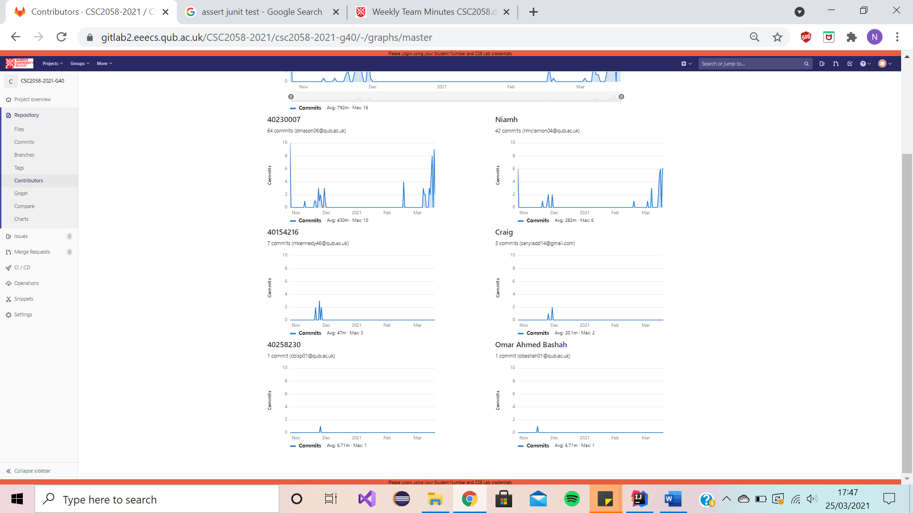

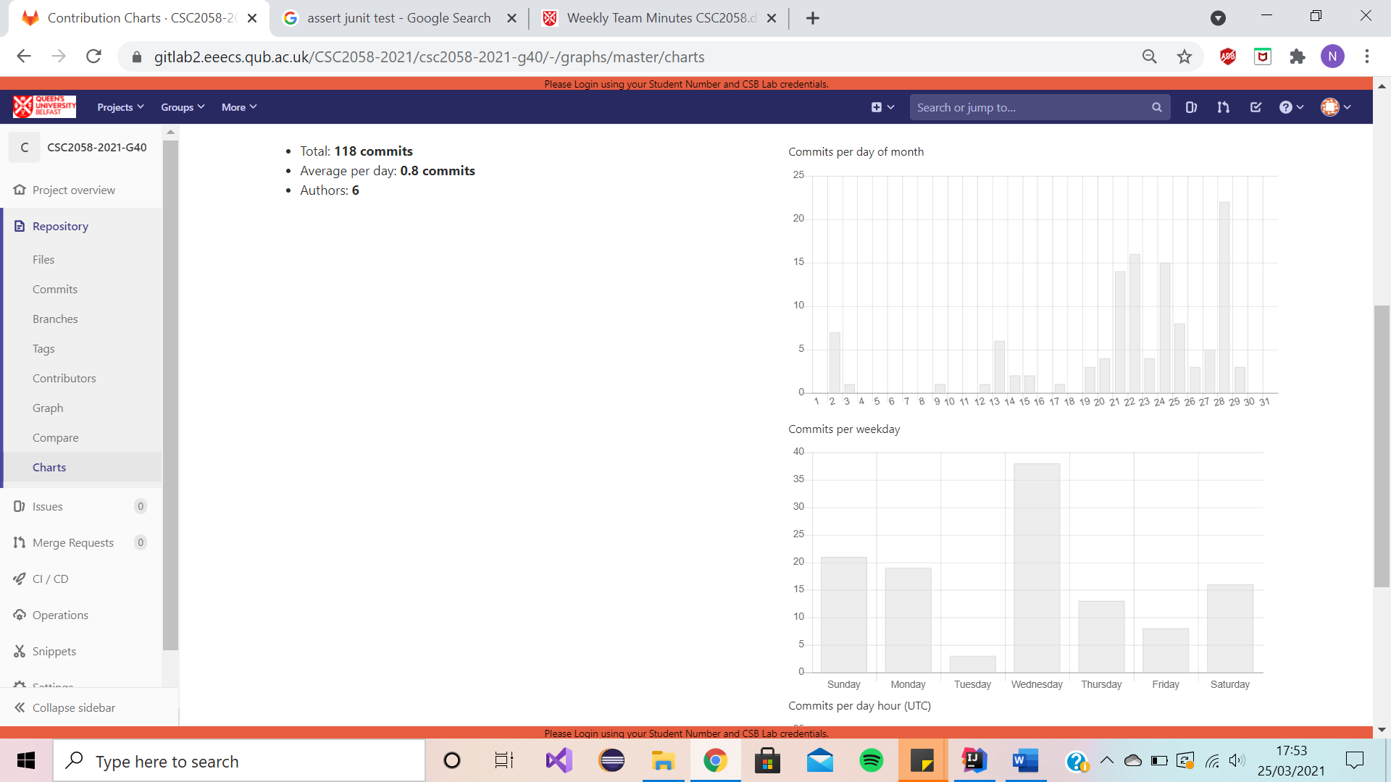

**Junit Test Runs**

**[N.M; D.M]**

Shown below are some sample screenshots of our Junit testing.

**ActionArea Junit Test**



**EventSquare Junit Test**



**NullSquare Junit Test**



**Player Junit Test**



**Priority Junit Test**

Secure System features

We used various security features, we have all attributes private with getters and setters for relevant fields. Here is some snippets of code of checks within the system:

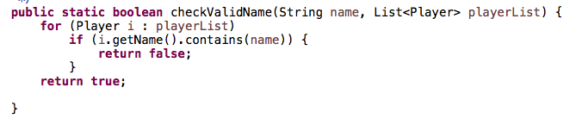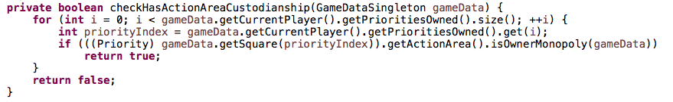



Future Opportunities

We have considered some secure features we would implement in the future.

* Adding a save game function- This would allow players to save their progress and continue with the game at a later stage.
* Adding a leader board- This would allow players to compete against each other (and previous gameplays involving themselves) to try place highly on the leader board.
* Timed gameplays- For example, playing a quick round of a set twenty-minute game or having a timer record their gameplay times. This would allow the players to try maximise their playing time effectively to try own and develop as many action areas as they can.
* Difficulty- The game will have various difficulties to choose from when launched and these will affect the Resources, Squares and Events and make them harsher on players.